MODY clinic referral pathway
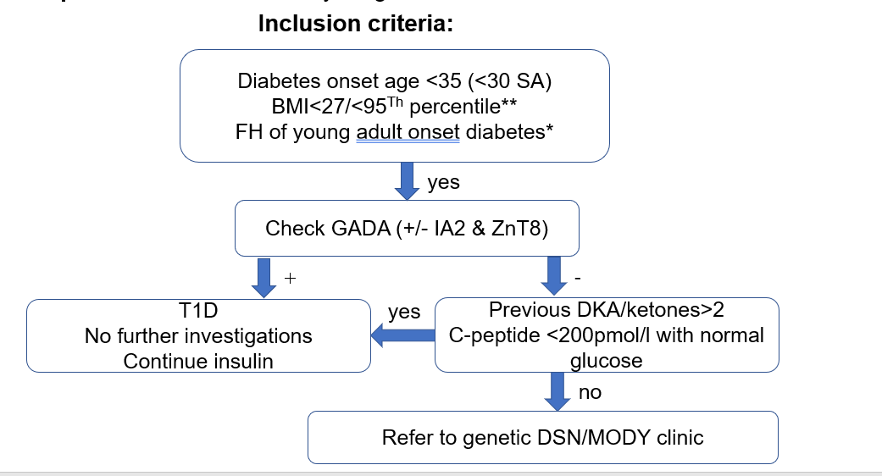
** if parent with diabetes for White Caucasian BMI<30; *exception HNF1B when 50% de novo

