**LibreView Data Review: Guideline for Diabetes in Pregnancy: Type 2 and GDM**

**Introduction**

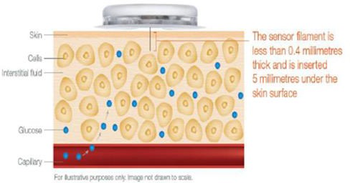The Libre sensor sits just under the skin and measures the glucose in the fluid around the cells (interstitial fluid). The glucose measured by the sensor is always “behind” what the blood glucose is measuring; usually around 5-10 minutes.

***Please Note:*** *the sensor glucose measurement will rarely be the same as the blood capillary glucose measurement (CBGM). This doesn’t mean the sensor is inaccurate; it reflects that they are measuring different things.*

**Objectives**

* Understand how to access and navigate the LibreView platform.
* Learn how to interpret various graphs and data reports.
* Utilise the data to make informed clinical decisions.

**How Often To Review**

Review data twice weekly (3-4 days apart) if sensor usage is either less than 60% or less than 90% of BG are in target range Otherwise review weekly.

**Accessing LibreView**

1. **Login**: Go to the LibreView website (www.libreview.com) and log in with your credentials. Denmark Hill: If you do not have an account, ask the diabetes technician to create an account for you. (The technician will need your email address). PRUH: Ask Lynne or Anuradha to do this.
2. **Dashboard**: Upon logging in, you will be directed to the dashboard where you can see an overview of patient data.

**Navigating the Platform**

* **Patient List**: Access the patient list to select the patient whose data you want to review. ‘Search patient’. Put in Surname or Christian name into the search box, and press enter
* **Patient Profile**: Click on the patient’s name to open their profile, you can check you have the correct patient by checking date of birth
* **Click Glucose History**
* **Click Glucose Reports**

**Setting the Report Settings**

* Do this for each patient you review. Once it is done, it will remain set for you for that patient (only for you, when another health care professional looks at the data, they will need to make the same changes so that they can review the data tailored for pregnancy)
* Change Patient Threshold Target Range from the parameters below to 3.5 – 7.8 mmol/l

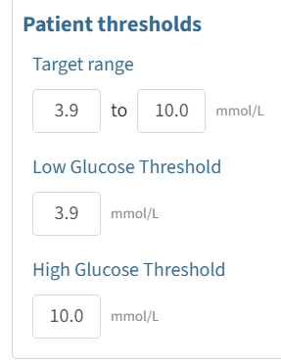

* Change the target range to 3.5 to 7.8
  + Low Glucose threshold 3.5
  + High glucose threshold 7.8
  + Set all the time frames to **1 week** (from 2 weeks)
  + Save
* **Data Reports**: The main sections to focus on during pregnancy are:
  + **Snapshot (NOT AGP report, as AGP reports 3.9 – 10 mmol/l despite having changed the target range)**
  + **Daily Log**
  + **Device details**

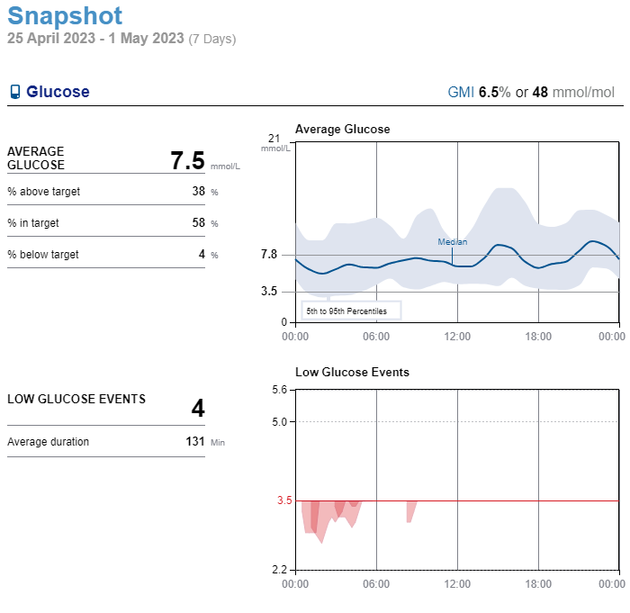

**Key Metrics to Review**

* **Snapshot: Time in Range (TIR)**: Percentage of time glucose levels are within the target range (3.5 – 7.8 mmol/l) Aim for a TIR of > 70%. However, see below for a more in depth look at data review. Often, even if the TIR is greater than 90%, there are changes that need to be made to lifestyle or medication
  + - * **Time Below Range (TBR)**: Percentage of time glucose levels are below the target range. Aim to minimize TBR, this should be < 4%.
      * **Time Above Range (TAR)**: Percentage of time glucose levels are above the target range. Identify and address factors contributing to high glucose levels.
      * **Average Glucose:** Ideally between 6.0 – 6.5 mmol/l. This figure can often be lower than 6 mmol/l, and that is ok if the TBR is not more than 4% or if they’re not using insulin

**Sensor Usage:** Should be >60%

* **Daily Log**: Identify trends and patterns in glucose levels throughout the day to tailor treatment plans.
* **Device details:** Check the person has their report settings at 3.9– 7.8 mmol/l.(it will not go lower than 3.9)

Check their alarm settings. Usually these are off initially, until the person is certain that the libre sensor is reading correctly. They the person may wish to have a low alarm of 3.5 mmol/l set, so that they can treat a hypo. However, be cautious about setting this alarm, as libre sensors commonly read too low especially overnight, so we advise the person to check their blood glucose if they get a low alert to confirm the glucose sensor reading.

# When to do finger-stick checks

The sensor can replace many finger stick glucose checks but there are times it is recommended that a finger stick check is made:

* To confirm a hypo and monitor recovery from a hypo.
  + Especially overnight reported hypos
* If the sensor reading doesn’t match how the person feels
* During first 24 hours of new sensor the sensor may not be as reliable as other times

**Sharing Data**:

* From any screen in the libre app, tap the “three lines” icon in the upper left corner.
* Tap Connected Apps.
* Tap on Libreview Connect or Manage.
* Tap Connect to a Practice
* Enter Connection information. Code 11457101 (KCH Diabetes Team) or PRUH code 21021964
  + Or An email invitation can be sent to woman from Libreview

**Interpreting Data Reports**

**Daily Log**:

**Daily Glucose Levels**: Shows detailed glucose readings throughout the day, helping to identify specific times of concern.

**Events and Notes**: Patients should ‘add note’ regarding all events like meals, exercise, and insulin doses to correlate with glucose levels.

**Glucose targets:**

• Pre-meals 3.5–5.2 mmol/l.

Aim <3 episodes of glucose readings above target per week for more than 1 or more hours at a time.

Aim <2 episodes of glucose readings below target per week. This only applies if using insulin.

**NB**: If the person is on Metformin alone, or diet and exercise, the TBR (time below range) may be more than 4% as Metformin does not cause hypos. However, if the glucose levels are confirmed with finger pricking to be below 3.5 mmol/l more than 4% of the time, decrease the Metformin dose.

**Care needs to be taken to review overnight and before breakfast readings.** BG **will not** be highlighted as above target if fasting BG 5.3-7.8 despite guidelines for FBG being 3.5-5.2 mmol/l, as it is not possible to set targets for both pre and post meals.

• 1 hour after meals 3.5 –7.8 mmol/l.

Aim <3 episodes of glucose readings above target per week

Aim for <2 episodes of glucose readings below target per week. This only applies if using insulin

• If glucose outside target, clinician will contact to discuss

If HbA1c is measured

Target is HbA1c <42 mmol/mol (<6.0%) (without disabling hypoglycaemia), ideally <37mmol/mol (<5.5%) or to be decreasing to this target

If HbA1c ≥37 mmol/mol (5.5%), it should rise by no more than 2 mmol/mol (0.2%).

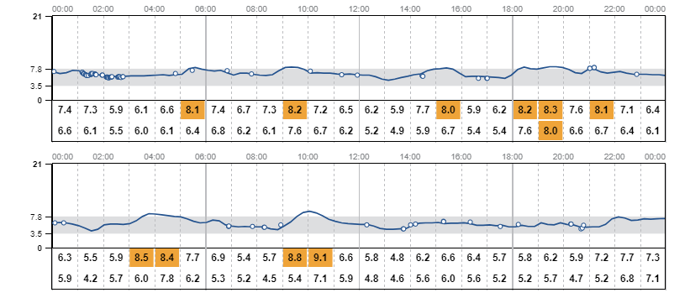

For Eg: This person’s time in range is 94%, but you can see that glucose remains above target for more than 1 hour after she has eaten. Medication needs to be increased

**Making Clinical Decisions**

1. **Assess Control**: Determine if the patient’s glucose levels are within the target range and identify areas needing improvement.
2. **Identify Patterns**: Look for recurring patterns of high or low glucose levels and potential triggers. Be structured about looking at the glucose levels.

Overnight, before breakfast, after breakfast, before lunch, after lunch, before evening meal, after evening meal, bedtime. And even write a little chart with these headings. Then one can look for patterns.

1. **Adjust Treatment**: Based on the data, make informed decisions about medication adjustments, dietary recommendations, and lifestyle changes.
2. **Patient Education**: Use the data to educate patients on how their actions impact glucose levels and motivate adherence to the treatment plan

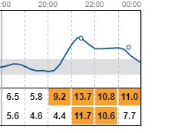

Figure Post-prandial hyperglycaemia, did woman inject pre-meal? Is there a repeated pattern? Does she need to intensify insulin or Metformin?

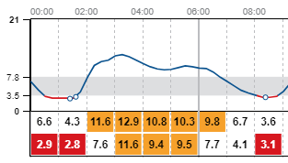

Figure Hypoglycaemia followed by hyperglycaemia. Did she over-correct? It is repeated, the next night. Did she overcompensate for reactive high? Does-bedtime basal needs to be reduced?

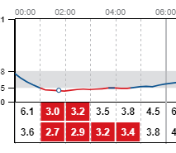

Figure Overnight hypo. Did she confirm with a finger stick measurement? Measured at 0200, but seems as not enough hypo treatment. Reduce bedtime basal? Educate on hypo treatment?

**Interventions:**

1. **Diet/exercise:**

Encourage 30-50g carbohydrate at every meal, aiming for 120-180g per day.

Insufficient carbohydrate increases risk of ketosis

Breakfast 20- 30 g carb /snacks 10-15 g. Lunch 30-40 g carb/snack 10-15 g. Evening meal 50-60 g carb

Review diet/exercise whenever glucose levels above target, particularly if glucose levels very different at the same time of day.

1. **Metformin**

Consider metformin (provided not contraindicated) if:

* Pre-breakfast and overnight: >3 episodes of glucose readings >5.2 mmol/l per week (note if pre-breakfast glucose ≥7.0 mmol/l consider starting insulin rather than metformin)
* One-hour post-meal: >3 episodes of glucose readings >7.8 mmol/l at ANY time of day per week (note if post-meal glucose ≥11.1 mmol/l consider starting insulin rather than metformin)

**c) Insulin**

* Insulin should be considered at diagnosis of GDM if OGTT shows fasting plasma glucose ≥7.0 mmol/l, or 2 hour plasma glucose ≥11.1 mmol/L.
* Consider starting insulin rather than metformin if libre glucose monitoring shows overnight and pre-breakfast readings >7.0 mmol/l or 1-hour post-meals ≥11.1 mmol/l.
* Once on metformin 1000 mg bd (or maximum tolerated dose) for one week OR if metformin not tolerated/contraindicated/declined start insulin if:
  + Pre-breakfast and overnight: glucose readings >5.2 mmol/l for most of the night >3 times per week. Start pre-bed basal insulin
  + One-hour post-meal: glucose readings >7.8 mmol/l at the same time of day >3 times per week. Start pre-meal rapid-acting insulin for the appropriate meal
* If insulin therapy declined, document and discuss with diabetes consultant or DSN.
* If glucose levels above target on insulin, increase appropriate dose.

**Use the GDM-Health guideline for how to start and titrate insulin**

**Follow-up**

• If libre traces visible & glucose levels are in target, libreview will be checked as above & the woman will be seen face-to-face by a diabetes educator at her planned midwife/obstetrician visits: 16-18, 24-25, 28, 31-32, 34, 36, 38, & 40 weeks of gestation. Face-to-face diabetes review may not be required at 38 & 40 week visits if there are no concerns.

• If the libre trace is < 60% visible or glucose levels are out of target, & this is not resolved within 2 weeks by remote review, the woman should be offered a face-to-face appointment in diabetes pregnancy clinic within 1 week. Such women will be reviewed face-to face at least every 2-4 weeks until management can be done safely again remotely.

* 1. • For women who are unable, or do not wish, to use GDm-Health® (e.g. unable to use the technology, no access to suitable smart phone, unable to speak English):
     + 1. o Email/telephone communication weekly (ensure on email/telephone list) & face-to-face 2-4 weekly
  2. *OR*
  3. o Face-to-face every 2 weeks

***Clinician refers to: Diabetes Specialist Nurse, Diabetes Specialist Dietitian, Diabetes Specialist Midwife, Obstetrician or Diabetologist***