**Managing glucose levels using CSII through labour**

A protocol for managing glycaemic control through labour and birth using CSII is shown in figure 5. This is based on a protocol developed by Peter Hammond, which several UK centres have been using since at least 2013 (A simplified version is presented in the DTN-UK guideline for managing CSII in hospitalised patients (ABCD-DTNUK 2017a)).

* The pump cannula and/or sensor should be sited well clear of the potential surgical field in case of emergency or planned caesarean section. The pump is best sited just below the rib cage posteriorly.
* An individualised VRII (plus glucose) should be prescribed in advance in case it is required.
* Women should have a cannula inserted.
* Glucose should be checked and recorded hourly. This can be sensor glucose. However, if the sensor glucose is out of target range 4-7 mmol/l a capillary blood glucose level should be checked before action is taken. In addition, capillary blood glucose should be checked at least 4 hourly.
* The woman should continue her usual basal infusion rates and give correction doses through the pump using individualised ISF and target 5 mmol/l.
* Target glucose range 4-7 mmol/l.
* If glucose remains above 7 mmol/l despite giving correction doses following the protocol, an individualised VRII (plus glucose) should be started and CSII stopped. Remove CSII and tubing and place in a suitable container (there is no need to turn off CSII nor to remove the subcutaneous cannula).
* If the woman or birth partner is unable or unwilling to manage CSII an individualised VRII (plus glucose) should be started and CSII stopped.
* Immediately after birth, basal rates should be reduced to the planned postpartum basal rates, or a 50% temporary basal rate can be used. As soon as possible after birth (and certainly before the first bolus) the woman MUST change the bolus calculator settings to her postpartum settings.
* If the VRII plus glucose is used, insulin rates should be halved at birth. CSII can be restarted once the woman is able to self-manage the pump. All settings should be changed to the planned postpartum settings. The VRII should continue for 60 minutes after restarting CSII.

**Managing glucose levels using CSII through planned caesarean birth**

Women who are fasting overnight prior to a planned caesarean birth are advised to check their glucose at 3am and on waking in the morning and take corrective action if glucose out of target range 4-7 mmol/l. Hypoglycaemia should be treated with oral quick acting carbohydrate, and women should inform the anaesthetist if this has been necessary. After an episode of hypoglycaemia during fasting, consider reducing the basal rate using a temporary basal rate setting. On the morning of the planned caesarean, the protocol in figure 5 should be followed from waking.

**Responsibilities of staff, the woman and her birth partner for women continuing CSII through birth**

The key to successful use of insulin pump therapy during labour, or prior to caesarean, and birth is to have a clear protocol which all staff on the labour ward are aware of, including not only the obstetric staff but other staff who may be involved, such as anaesthetists. The birth partner should be closely involved in planning for what is going to happen at the time of birth so that they are able to manage the pump, if needed.

While the woman remains on CSII, the woman and her birth partner are responsible for checking and documenting glucose hourly, giving correction via CSII, adjusting basal rates and pump settings as required including after birth. The midwife is responsible for ensuring the woman / birth partner remains able and willing to manage the CSII, that glucose is checked and documented hourly, and that if glucose is persistently (see below) above 7 mmol/l, VRII plus IV glucose is started and the CSII stopped. If the woman is on VRII plus glucose, the midwife is responsible for checking capillary blood glucose (NOT sensor glucose) hourly and adjusting VRII rates as prescribed.

**Figure 5: Protocol for managing glucose levels for women continuing on insulin pump therapy during labour and birth or during casearean birth.**

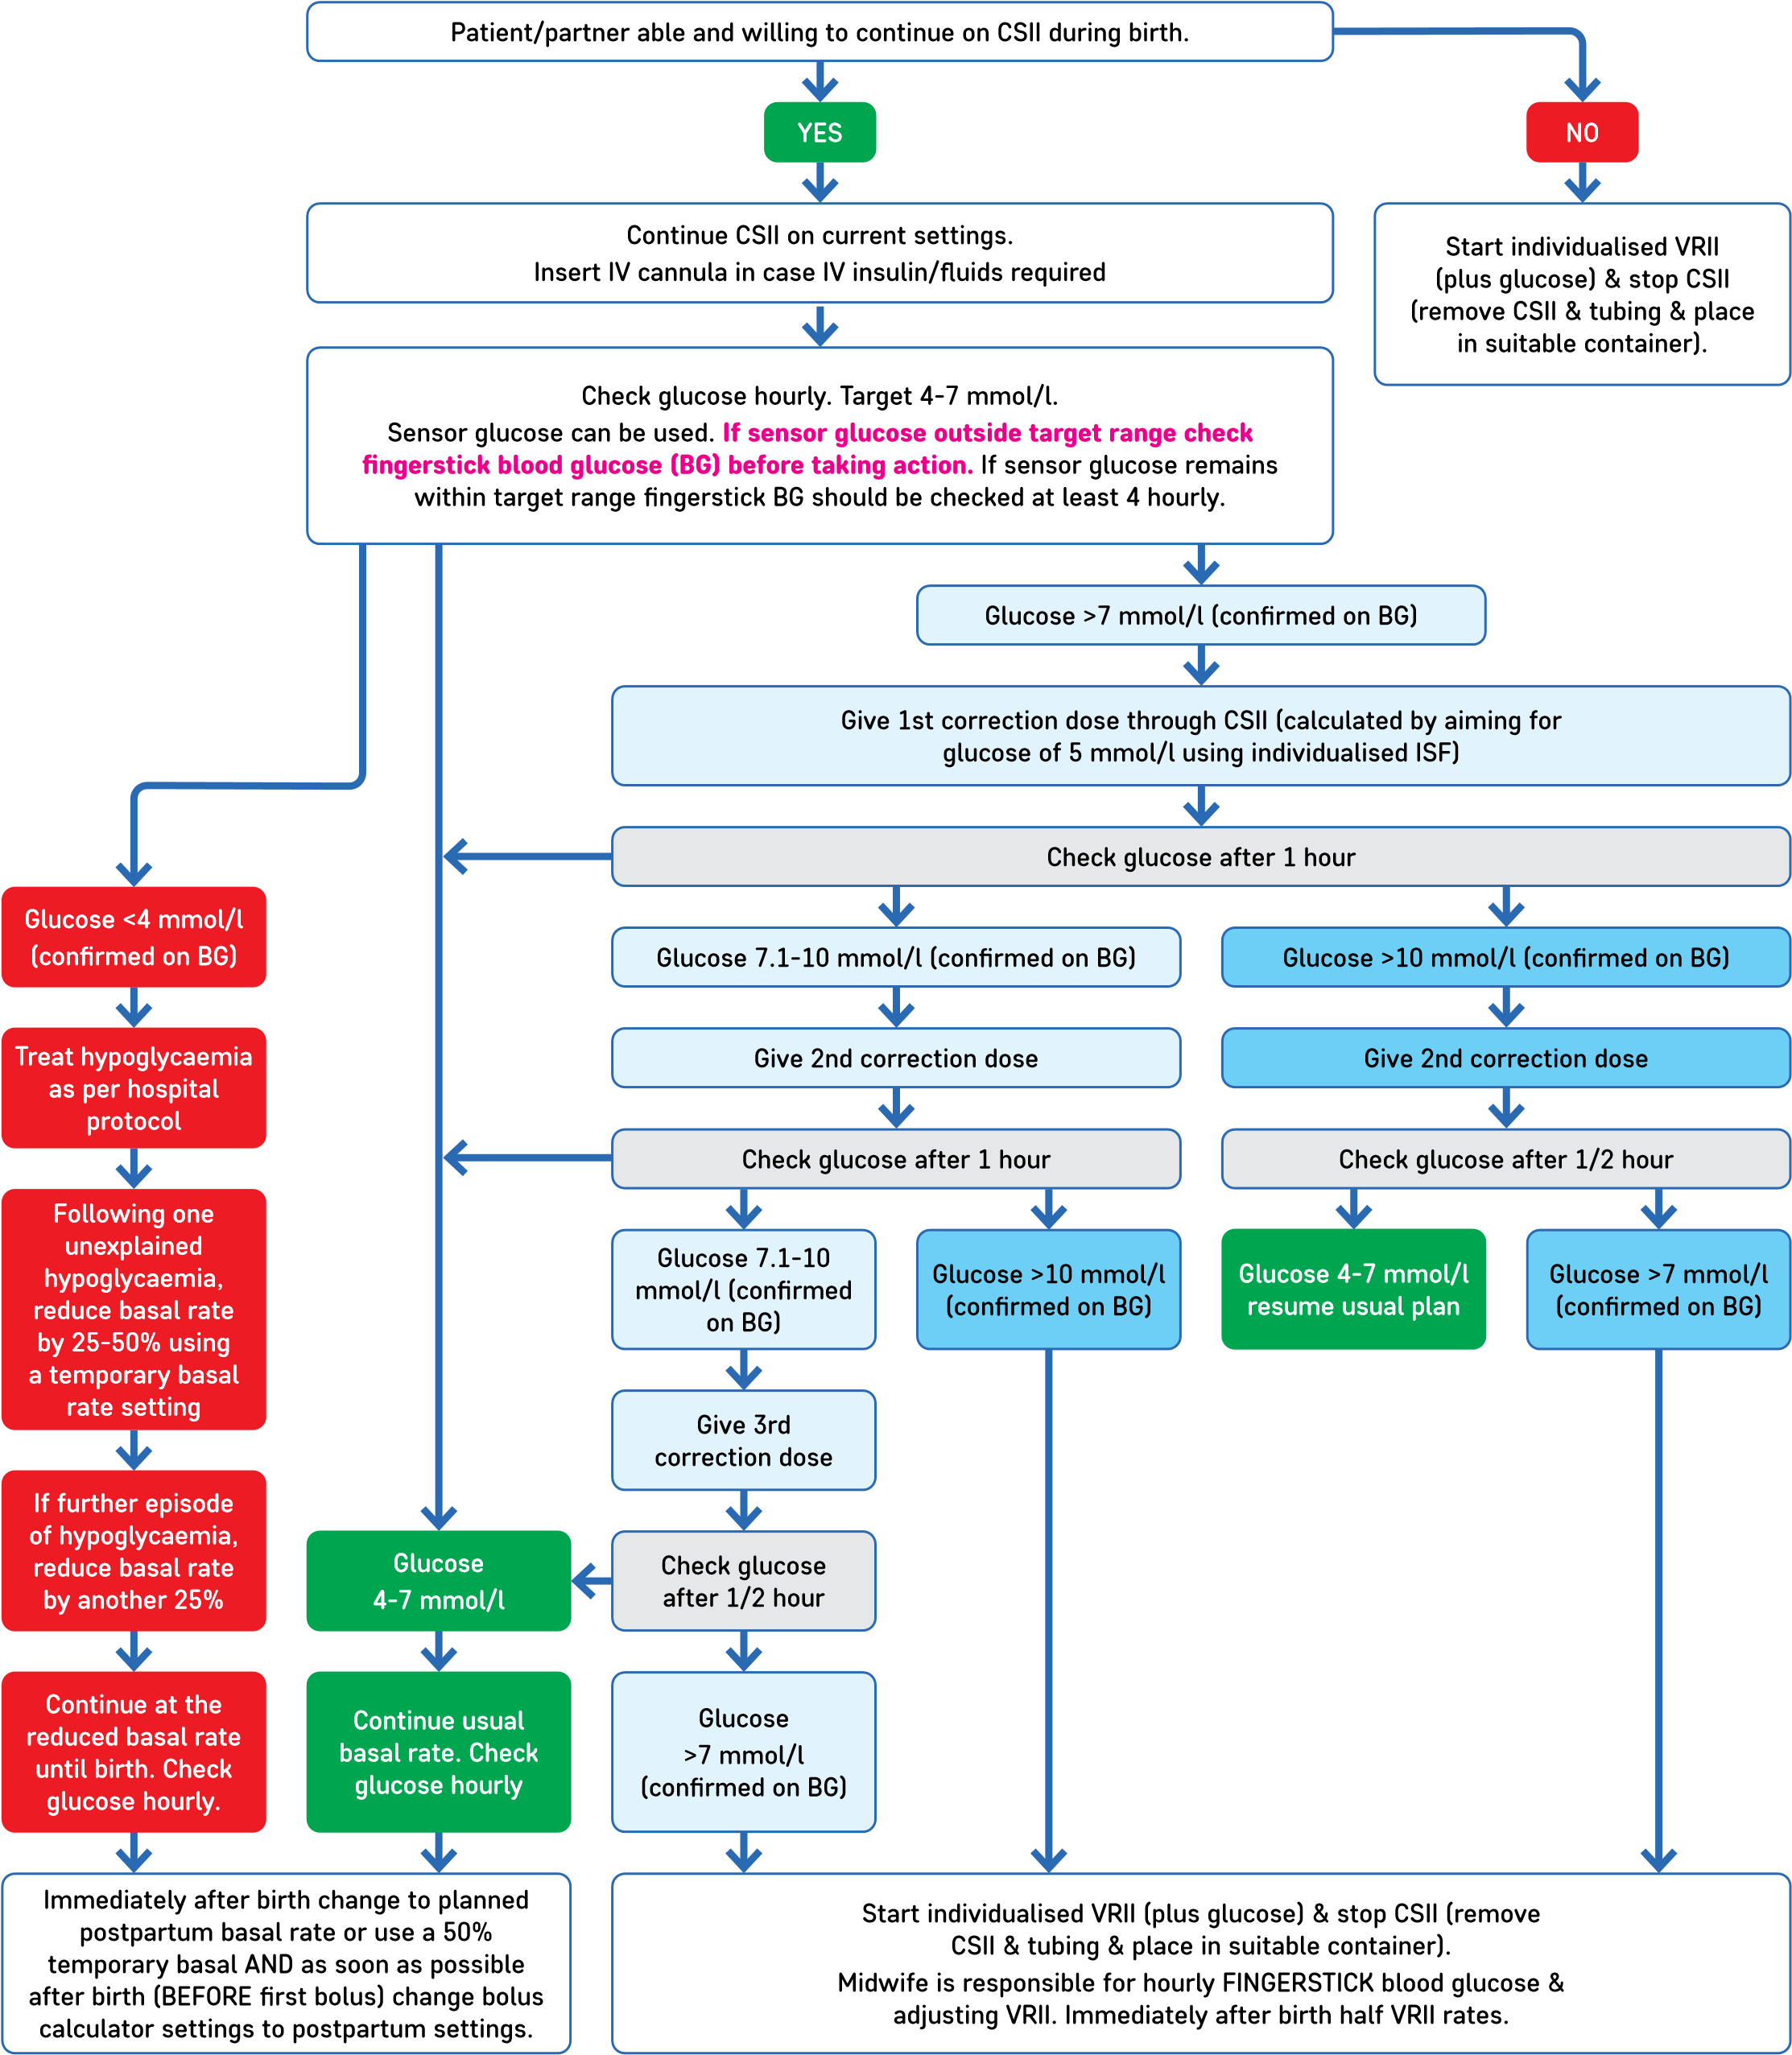**Start once in established labour, or on waking on the morning of a planned caesarean, or when made nil by mouth for an emergency caesarean**