**Checklist for Preparing, Carrying Out Training, and Reviewing data for a Hybrid Closed Loop System in Pregnancy**

**Preparation**

1. **Multi disciplinary Team Meeting**

* Discuss the suitability of the hybrid closed loop (HCL) system for pregnancy. This discussion should include people using other pumps in pregnancy.

1. **Discuss pros and cons with patient**

* Pros – More time in range, fewer hypos, less maternal weight gain, less fetal weight gain
* Cons – Pumpcart or reservoirs hold 160 units, Need to use Android phone, Increased risk of DKA when there is cannula failure

* Explain the basic concept of how the pump will deliver insulin to meet the individual’s needs (type of insulin, basal and bolus settings)

1. **Educator arrange for Hybrid Closed Loop CamAPS fx pump start**

* Write to GP asking for NovoRapid pumpcart x 4 boxes, and to continue other insulin – quick acting and background for emergency use in case of pump failure.
* Check the patient has an Android phone, and that it is compatible. To check it is compatible, ask them to download Dexcom G6 app. (even if they will be using libre 3). G6 Dexcom app is the most useful indicator that the phone is compatible.
* If they do not have a compatible Android phone ask the ordering team to order this as well. (called Digital Essentials Pack)
* Order Ypsopump/CamAPS and consumables The ordering team need to know to order, pump, phone (if required) CamAPS app, and consumables. Advise which sensor to order on this email too (either Libre3 or Dexcom6)

|  |  |  |  |
| --- | --- | --- | --- |
| MYOYP1851 | mylife YpsoPump Orbit micro | 5.5 mm | 45 cm (18") |

Use steel cannula in pregnancy to minimise the risk of cannulas bending and causing occlusion of insulin

* Arrange training date (usually 3rd Tues of the month in the afternoon)
* Ask the person starting the pump if they give permission to share their email with Ypsomed person, then Email Jeevan (or Ypsomed person) about the Hybrid Closed Loop start. [Jeevan.Kumari@ypsomed.com](mailto:Jeevan.Kumari@ypsomed.com)
* Give the following to the person starting the pump so that they can do the training:  (see ‘settings sheet’ from Yspomed)
* Advise the patient about doses of MDI to take on the day of pump start
* [BP-Pregnancy-DTN-V2.0.pdf (abcd.care)](https://abcd.care/sites/default/files/site_uploads/Resources/DTN/BP-Pregnancy-DTN-V2.0.pdf) pg 8
* Total Daily Dose
* Carb Ratios
* Max Bolus of 30
* Personal glucose target

1. **Patient checklist pre training (at least 1 week before training)**

* Compatible Android phone and phone charger
* Pumpcarts received
* Pump and consumables received
* Pre training done and a code generated
* Has blood ketones strips and meter

1. **Training for the person starting CamAPS FX and Ypsopump**

**Email to send to person starting HCL re Training: (email all in “ ”)**

**“**[Welcome to the CamAPS FX training portal (camdiabtraining.com)](https://gbr01.safelinks.protection.outlook.com/?url=https%3A%2F%2Fwww.camdiabtraining.com%2Fhome.html&data=05%7C02%7Chelenrogers%40nhs.net%7Cd421a23977f94e7f79a108dcc81ca2a1%7C37c354b285b047f5b22207b48d774ee3%7C0%7C0%7C638605272512010779%7CUnknown%7CTWFpbGZsb3d8eyJWIjoiMC4wLjAwMDAiLCJQIjoiV2luMzIiLCJBTiI6Ik1haWwiLCJXVCI6Mn0%3D%7C0%7C%7C%7C&sdata=pFZC5m%2FEFGH7toM2OMuEvE7WT7DsVXmbcSqRlj3uwcA%3D&reserved=0) – you need to do the training marked as ‘**Person with Type 1 Diabetes or Family Member’.**

**This training is mandatory and the mylife Loop start cannot go ahead without it.**

***Once completed, you will receive an access code on a certificate – please reply to this email with a copy of the certificate and make a note of the access code.***

**Compatibility**

If the Android phone is compatible with the Dexcom G6 app, it will also be compatible with the mylife Loop system. [Phones that work with Dexcom apps | Dexcom](https://www.dexcom.com/en-us/compatibility/g6) (ignore the IOS phones)

Dexcom 6 sensor:

* You will be able to continue to use your existing Dexcom G6 running sensor in the mylife Loop system, but please make a note of your current transmitter serial number.

Libre 3 sensor:

* If your phone is compatible with the FreeStyle Libre 3 app, you need also to check that it is compatible with Dexcom g6 app (even though you are not using G6) [Phones that work with Dexcom apps | Dexcom](https://www.dexcom.com/en-us/compatibility/g6) (ignore the IOS phones)

* **You will need to start a new FreeStyle Libre 3 sensor in your mylife Loop start** training. Please make sure you bring a **new unopened libre 3 sensor** to your mylife Loop appointment.

Once you have confirmed that your device is compatible, you can download the mylife CamAPS FX app and create a CamAPS FX account – but stop when you see the Welcome screen as we will go through this together. **Make a note of your username and password for this account and bring with you.**

**On the day of your mylife Loop start you will need:**

* Your pre-filled insulin NovoRapid pumpcart cartridges, dispensed from your pharmacy.
* Your current weight in kg.
* Your total daily dose of insulin from the past 5 / 7 days – this should include both basal and bolus combined.
* Your personal Glooko account log in details. If you don’t have this, we will set this up with you when you come for training
* A spare CGM sensor (and transmitter if required).
* Any mylife YpsoPump and supplies that have been sent directly to you.
* Android phone (fully charged) with mylifecamaps app downloaded (remember username and password)
* Mylife CamAPS FX app login details
* Post training access code”

**Training to be used by the Health Care Professional**

**Training checklist**

|  |  |
| --- | --- |
| **Name and MRN number of person being Trained**      **Pump Serial number** | **Name of Trainer**      **Signature when client has been taught** |
| **Date:** |  |
| Which CGM will be used? Dexcom G6 or Libre3 |  |
| General: |  |
| Components of the mylife YpsoPump system. Water resistance and watertightness |  |
| How and where to wear the pump |  |
| 24 hour service / order procedure / pump insurance / replacement terms |  |
| Putting into operation |  |
| Inserting a battery and performing the self-test. Battery recharge and battery life |  |
| Setting time and date |  |
| Inserting an insulin cartridge / reservoir |  |
| Priming the infusion set |  |
| Operation |  |
| Navigation User interface Run and stop modes |  |
| Basal rates |  |
| Programming basal rate profiles A and B. How to change the basal rate (pausing run, and then restarting) |  |
| Switching between basal rate profiles |  |
| Coming out of Automode and using Temp Basal Rate |  |
| Bolus |  |
| Setting and changing the bolus increment |  |
| How to give a manual bolus via the pump if phone is lost/App failure |  |
| Ensure max bolus is 30. If patient needs more than 30 units for bolus, they will need to put the carbs as half and repeat the bolus. Eg, for 60 g carb, put in 30g twice. |  |
| Discuss timing of bolus in relation to meals, from 0 – 60 mins depending on hypos and trimester |  |
| Setting and stopping a standard bolus |  |
| Infusion set and cartridge / reservoir |  |
| Changing the pumpcart / reservoir – when and how |  |
| Changing the infusion set, every 2 days because of steel cannula  Priming the infusion set |  |
| Attaching / detaching the infusion set  Suspending the pump if >15 mins off pump (eg showering) |  |
| Priming the cannula (if not using steel cannula) |  |
| **Never** change infusion set before bed. Best before a meal |  |
| Data / History |  |
| Displaying therapy data. Displaying alarm history |  |
| Safety functions Warnings and alarms |  |
| Functions and settings |  |
| Changing time of day and date |  |
| Advanced function capabilities eg boost, ease off |  |
| Set up data sharing platform account - glooko and advise how to connect |  |
| Continuous Blood Glucose Monitoring and alert settings (see later, page 6) |  |
| Application of CGM |  |
| Dexcom G6 |  |
| Freestyle libre 3 |  |
| [YpsoPump Video Tutorials – mylife Academy (mydc.pw)](https://gbr01.safelinks.protection.outlook.com/?url=https%3A%2F%2Facademy.mydc.pw%2Fyp-vid%2F&data=05%7C02%7Chelenrogers%40nhs.net%7Cd421a23977f94e7f79a108dcc81ca2a1%7C37c354b285b047f5b22207b48d774ee3%7C0%7C0%7C638605272512027084%7CUnknown%7CTWFpbGZsb3d8eyJWIjoiMC4wLjAwMDAiLCJQIjoiV2luMzIiLCJBTiI6Ik1haWwiLCJXVCI6Mn0%3D%7C0%7C%7C%7C&sdata=Cwu0u1PZBJ8hB%2FXwWqkK3vYvfYBcpaMDwRvW8v1OElA%3D&reserved=0) |  |
| Linking the CGM to the Insulin Pump |  |

|  |  |
| --- | --- |
| Counsel on hypoglycaemia treatment options when using HCL. Remind that only 7 g rapid acting CHO needed.  Enter hypo treatment onto the app as hypo treatment |  |
| Managing unexplained hyperglycaemia, Sick Day rules and C:\Users\helen rogers\AppData\Local\Microsoft\Windows\INetCache\Content.MSO\41C4E5D6.tmpketones, provide literature on this |  |
|  |  |
| Aware daily living advice relating to: |  |
| Travel and Pump/cannula failure – change date and time when arrive at new time zone. Take plenty of supplies. Know back up doses, and have pens **&** needles available for emergency use |  |
| Going for investigations : remove CGM, infusion set and pump (put into suspend mode) before going for MRI. Contact DSN prior to procedure. Other investigations the pump and CGM may remain in situ |  |
| Going into hospital: reviewed on an individual basis. However at least 4 hourly finger prick to ensure CGM is reading similarly to CBG |  |
| Troubleshooting: if out of automode and pump not connecting, Phone Ypsopump helpline   * keep android phone charged * keep spare batteries for pump handy * keep spare pumpcart cartridges |  |
| Suggested Personal glucose targets   * 1st trimester 5.5 mmol/l * 2nd trimester 4.4 – 5.0 |  |

**Reviewing Downloads**

**Glooko**: Enter patient name and check it is the correct patient by confirming the date of birth

If Glucose summary is not showing target range 3.5 – 7.8 mmol/l, change under ‘Profile’ (next to patient’s name)

**Check 1 week of data (**rather than 2 weeks, things change quickly during pregnancy)

**Time in Range**: Aim for >70% after the first few weeks, and >80% during the second and third trimesters

**Time Above Range**: Aim for <25%, and <15%% during the second and third trimesters

**Time Below Range**: Aim for <4%, with none ‘very low, below 3.0 mmol/l’

**Average Glucose**: Aim between 6 – 6.5 mmol/l

|  |  |
| --- | --- |
| C:\Users\helen rogers\AppData\Local\Microsoft\Windows\INetCache\Content.MSO\AE7E0854.tmp | **Time Above Range**: Aim for <25%, and <15%% during the second and third trimesters |
| **Time in Range**: Aim for >70% after the first few weeks, and >80% during the second and third trimesters  **Average Glucose**: Aim between 6 – 6.5 mmol/l |
| **Time Below Range**: Aim for <4%, with none ‘very low, below 3.0 mmol/l’ |

*Figure 1 TIR targets, adapted from Battelino 2019. More research is needed on pregnancy. Be aware that AGP cannot capture 1hr post prandial BG. Review of daily patterns is needed*

See DTN [BP-Pregnancy-DTN-V2.0.pdf (abcd.care)](https://abcd.care/sites/default/files/site_uploads/Resources/DTN/BP-Pregnancy-DTN-V2.0.pdf)

Pages 32 – 40 to learn how to review the data.

**Top Tips**

Check weekly that Correction Factor (or insulin sensitivity factor) is either 120/TDD (<20 weeks)

Or 100/TDD (>20 weeks). This is only a backup if the app goes out of ‘automode’ (it does not affect the algorithm)

Check backup basal matches, or is approx 10% more than what the pump is giving. This is only a backup if the app goes out of ‘automode’ (it does not affect the algorithm).

Check on the pump that basal is showing A -> B. And that profile A is set as back up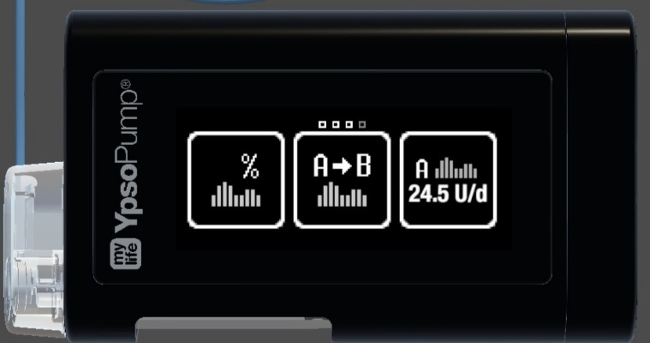

Check on glooko the % of time in automode, and trouble shoot if there are issues

Check the person is entering their weight into the app (fortnightly after >20 weeks)

Check the person is changing infusion sets every 2 days (steel cannula), 2 – 3 days (plastic cannula)

Check the timing of bolusing before meals: 1st trimester 10 – 15 mins, 2nd trimester 20 – 30 mins, 3rd trimester 45 – 60 mins

Check monthly (usually at Dr visit) they have pens/needles for backup, and that they have a copy of ‘unexpected hyperglycaemia’ available, and understand what to do.

**Check alerts recorded settings on glooko**, and check that the person can hear them. If not, discuss with Ypospump how to alter the phone’s settings (if they are on mute). Or change the mylifecamAPSFX settings from vibrate to sound.

High alert settings àAlert on high à During usual waking hours 12-15 mmol/l, à During usual sleeping hours 8-10 mmol/l

Low alert settings à Alert before low (if they wish). Alert on low à4.0 (so that they can eat, rather than treat to prevent a hypo).

No more than 6-8 glucose alerts per 24 hours. More than this risks ‘alert fatigue’ and suggests something needs to be changed (which might be the insulin delivery ‘settings’, pre-emptive action to avoid the alert, the response to the alert or the alert settings)

**Options for managing post-meal glucose excursions:**

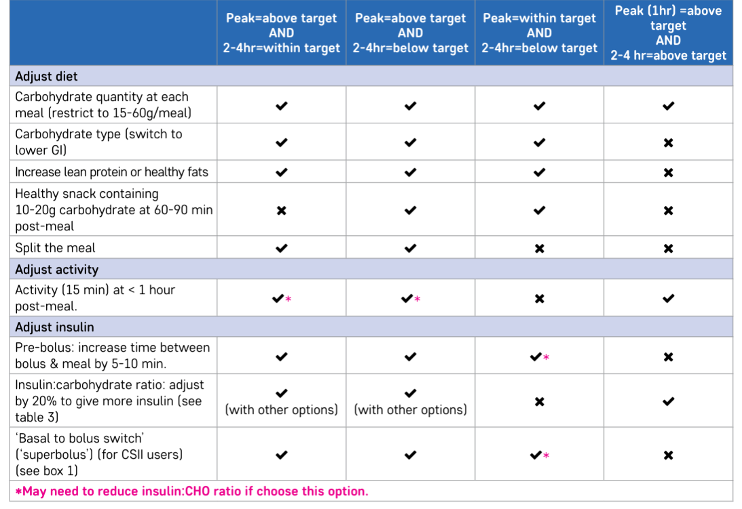

Source: DTN [BP-Pregnancy-DTN-V2.0.pdf (abcd.care)](https://abcd.care/sites/default/files/site_uploads/Resources/DTN/BP-Pregnancy-DTN-V2.0.pdf), p33

**Managing Steroid on HCL Ypsopump**

Use Boost. Start when glucose >7.

If glucose remains 8 mmol/l or above after 2 hours, take pump out of auto mode and set up VRIII (no glucose). Use pump to give bolus insulin for meals

48 hours after steroids revert to auto mode

**Managing HCL during C/section or Labour**

Use the documents in Diamond drive à Pregnancy Guideline and other documents à Pumps in Labour or C Section à Ypsopump and CamAPS FX

Considerations: If the partner is competent and you are happy that they have succeeded in understanding and carrying out the training, then you can write to that effect on EPIC   
EPIC à Obstetric History à Obstetric Comments

If you have doubts about it, discuss at MDT and record on EPIC under Problem list à Complication associated with Insulin Pump, and the person will use VRIII during C/section or Labour

**After Delivery of Baby**

Stay in automode

Use ease off if glucose is below 6 mmol/l

Keep hypo treatment close by

Review by diabetes team pre discharge

Arrange follow up appointments with diabetes team

**In CamAPS app on the phone: This should be done before the first meal!**

Settings à Personal glucose target 6 or 6.5 mmol/l

Settings à change weight. Update pre-pregnancy weight

Settings à Bolus Calculator à Insulin-to-carb ratio. Change insulin to carbohydrate ratio to agreed ratio or 1:15g for all meals

Settings à Bolus Calculator à Correction Factor. Change to agreed correction factor, or change to 4 mmol/l

Alerts à Change the alert settings: low threshold 4 mmol/l, high threshold 12-15 mmol/l (these can be individualised)

**On Ypsopump:** Ensure Basal rate B is showing (see pages 17 – 19 [YPU_IFU_QSG_V1.5.2_MSTR-CA-en.pdf (mylife-diabetescare.com)](https://www.mylife-diabetescare.com/files/media/03_Documents/01_YpsoPump/IFU/1.5.2/YPU_IFU_QSG_V1.5.2_MSTR-CA-en.pdf)

**On Glooko:**

Next to the patient’s name à Profile. Set target range 3.9-10 mmol/l à save

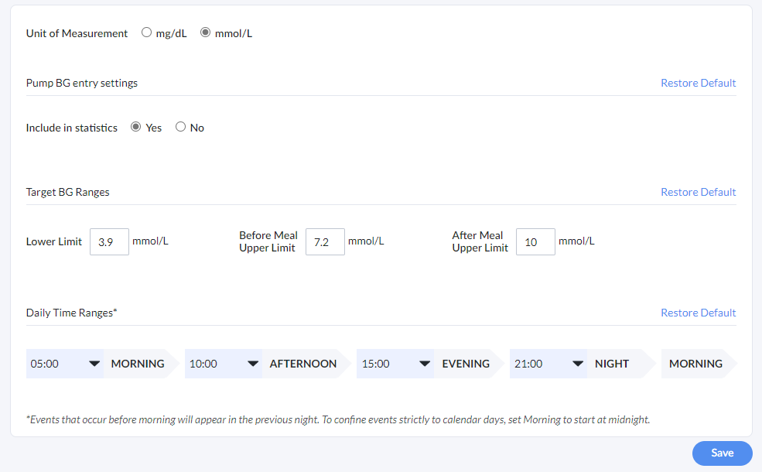 *Figure 2 Glooko Profile*

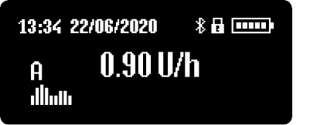

*Figure 3 Status screen*

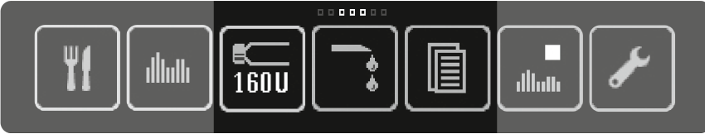

*Figure 4 Main menu. From left to right: Bolus, Basal rates, Cartridge change and current cartridge level, Prime infusion set, Data, Stop/Run mode, Settings*