**Omnipod 5 Pump start workbook**

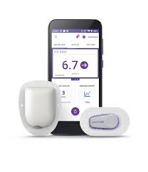

This workbook is sent as a PDF.

We recommend that you view this workbook online so you have access to the links;

If you have problems viewing this PDF, get Adobe Acrobat Reader: PDF Viewer, Editor & Creator on your computer or phone/tablet

1. **Android or tablet**: Install the free APP:- <https://play.google.com/store/apps/details?id=com.adobe.reader&hl=en_GB>
2. **iPhone or iPad**: install the free APP: <https://apps.apple.com/gb/app/adobe-reader/id469337564>
3. **Computer:** Install the free software: <https://get.adobe.com/uk/reader/otherversions/>

**Introduction**

**How we are running our pump start sessions**

We have to make sure we provide training and support to enable you to safely start your insulin pump. We have developed a package with a combination of self directed learning, both reading and watching videos. You must complete this self-directed learning before you attend the pump start session with the MPFT diabetes team. There may be other patients wishing to start the same insulin pump at the same time and you will be in the session together. The session will be an opportunity to put into practice what you have learnt and to ask questions.

If you have not completed the tasks as instructed, you will not be allowed to carry on with the session and the pump start will be postponed. If you are having difficulty completing the self-directed learning or accessing the videos and other materials, please let us know as soon as possible so we can help with this.

Throughout the workbook there will be a series of videos, reading and tasks. We have used the following symbol to help identify the different tasks:

*The diabetes team at MPFT would like to thank University College Hospital London for sharing content used in this workbook.*

 A Task you need to complete

After you have started on your insulin pump, you will have regular follow up with the diabetes team. We advise that at the time of each follow up and for 6 weeks after your pump session you are in your usual routine, i.e. avoid times when you know life is going to be busy or stressful (e.g.moving house, new job, holidays, exams).

*\*\*Settings in your Omnipod 5 hybrid closed loop system (HCL) will be different to those you have used with standard insulin pump therapy. Your settings will be reviewed before you start on your new pump\*\**

**Please read the whole of the workbook and watch the videos before your pump start session.**

***Useful contact numbers and websites***

**Dexcom**

Technical Support Tel: 0800 031 5763 Mon-Fri 07:00hrs-18:00hrs. Sat-Sun 08:30hrs-16:30hrs

Dexcom replacement sensors online [www.dexcom.com/UKIETechsupport](http://www.dexcom.com/UKIETechsupport)

Dexcom customer services Tel: 0800 031 5761

**Insulet**

Customer service Tel: 0800 011 6132

Website to order supplies: <https://www.omnipod.com/en-gb/reorder-pods>

**Glooko**

Tel contact: 0207 795 8191

Email: [support@glooko.com](mailto:support@glooko.com)

**MPFT Diabetes Team**

Tel contact (office): 01889 527038

Email: [diabetes-south@mpft.nhs.uk](mailto:diabetes-south@mpft.nhs.uk)

Webpage: <https://www.mpft.nhs.uk/services/diabetes-services-adults>

**Part One**

This section of the workbook is the preparation for you to start on the new hybrid closed pump system.

***Aims***

By the end of pump upgrade we aim for you to:

* Be able to use the Omnipod 5 HCL system safely and effectively
* Be able to download your pump, understand the reports and think about what changes might be needed

**Expectations**

**What you can expect from the MPFT diabetes team:**

* We will provide you with the tools you need to move onto your new pump safely
* We will put you safety and wellbeing about everything else
* We will provide information and pre-course reading before your pump start
* We will ensure you have the correct equipment before your session
* We will ensure that the core values of MPFT are embedded in all consultations. These are: Putting people at the heart of what we do, Empowering people to improve care & wellbeing & Delivering better health, better care in partnership.

**What MPFT diabetes team expects from you:**

* Complete the workbook before your pump start session.
* Attend the session on time
* Follow all the instructions in the workbook
* Ask questions if you do not understand
* Collect prescription items from your GP prior to the pump start session
* Do **NOT** put insulin into the pump and start using before the agreed time
* Create a Glooko account to upload and share information with the team
* Contact Dexcom or Insulet to deal with any technical issues
* Attend follow up clinic appointments regularly.

**System Use**

* Use the system in HCL mode at least 90% of the time
* Wear sensors 90% of the time
* Give the new system at least 9 days to start working well as it can take 9-12 days for the system to adapt to your insulin requirements.
* Aim to spend 70% of the time within the agreed target range, contact the team for advice if you are not reaching this goal between appointments.

**Understanding insulin pump therapy**

**What is insulin pump therapy?**

An insulin pump is an electronic devise that enables delivery of insulin throughout the day and night at adjustable doses to support management of diabetes. Please click on links below for more detailed information.

1. [https://www.nhs.uk/conditions/type-1-diabetes/managing-insulin/insulin-pumps**/**](https://www.nhs.uk/conditions/type-1-diabetes/managing-insulin/insulin-pumps/)
2. <https://www.diabetes.org.uk/guide-to-diabetes/managing-your-diabetes/treating-your-diabetes/insulin-pumps>
3. [Type 1 Technology & Resources - DigiBete](https://www.digibete.org/type-1-technology-resources/)



**What is Hybrid closed loop (HCL) pump therapy?**

Hybrid closed loop systems use and insulin pump and glucose sensor together to adjust insulin in response to glucose levels. A hybrid closed loop system can manage your glucose levels when you are sleeping, during the day you need to give bolus insulin for food and make adjustments to prevent low or high glucose levels with sports and activity.

Watch the videos below about how HCL systems work;

<https://www.diabetes.org.uk/guide-to-diabetes/diabetes-technology/closed-loop-systems>

**The Omnipod 5 System, Pods and Controller:**

The Omnipod 5 system is made up of 3 parts:

1. The Omnipod 5 controller (handset)
2. Pods with smart adjust technology
3. Dexcom G6 sensor

The controller is used to give insulin for food and corrections, set up a basal profile, glucose and bolus settings. You will also use the controller to activate and deactivate the pods.

The pods are waterproof up to depth of 7.6 meters for 1 hour.

The pods contain insulin, they can be worn for up to 3 days and can be filled with 200units of insulin. You will learn how to fill a pod at your pump start session.

The Dexcom G6 sensor measures your glucose levels and must be started in the Dexcom app.



Please review the following videos;

* Getting started with Omnipod 5:

<https://youtu.be/EHnAtJkHA0E?si=ttG90PBFgeCZkG4t>

* Omnipod 5 system Pod activation:

<https://youtu.be/u_a79jIadQU>

* Smart Adjust Technology video:

<https://youtu.be/vMDWPWSBFGQ?t=320>

The Omnipod 5 guidebook is also available at the link below. A copy of the guidebook will also be provided at your Omnipod 5 pump start.

* Omnipod 5 user guide:

<https://www.omnipod.com/sites/default/files/Omnipod-5_User-guide.pdf>

**Where to wear your pods:**

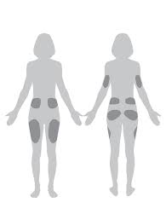

You can wear your pods on the upper buttocks, abdomen and legs.

The pod must be 3 inches away from the sensor/transmitter and the must be in direct line of sight.

**Pod Changes**

You need to change the pod every 2-3 days.



Do NOT change you pods at night/just before bed. You need to be able to check your glucose levels for 2-3 hours after your pod change.

**Skin care advice and tips:**

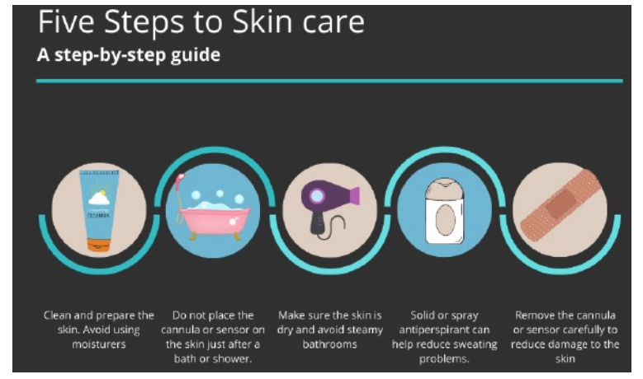

* Clean the skin with an oil free soap and dry thoroughly. Do not use an oil containing moisturizer on the area.
* Do not place immediately after a shower/bath or in a steamy bathroom - minimize humidity with hairdryer or apply in a dry environment.
* Solid or spray antiperspirant (unscented) may help with skin prone to sweating. Apply thin layer, wait 10–15 min, wipe off excess and prepare site.
* Barrier films may help prevent mild skin irritation from adhesives, although glucose sensor manufacturers recommend not using barrier creams and patches, as it may affect how the sensor works.
* If you are having skin reactions, contact the diabetes team to discuss.

**Highs, Lows and Sick day rules:**

You will still need to manage some high and low glucose levels using your HCL system. This will be different to how you manage highs and lows sick days on injections or on a manual pump.

It is important to know how to manage highs and lows and sick days to stay safe.

Hypo treatments on HCL systems should be no more than 10g carbohydrate. Big hypo treatments can cause rebound hyperglycaemia. Always wait 15 minutes before re-treating to give the glucose time to rise.

Remember if the glucose levels are 14mmol/l or more for more than 90 minutes check for blood ketones. If your level is 14mmol/l or more and you feel unwell check for ketones don’t wait.

**Hyperglycaemia:**

**Managing High Glucose levels – Hybrid Closed loop systems.**

If glucose is 14mmol/L or above check for blood ketones.

* If ketones are below 0.6mmol/L- follow ADCC (below)
* If Ketones are 0.6mmol/L or above follow sick day rules (below)

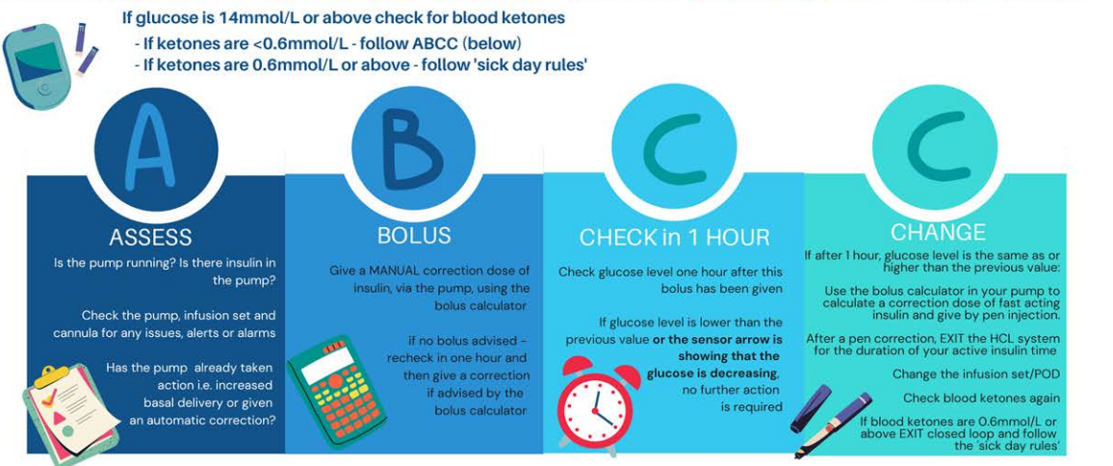

You should make standard checks on the pump for blockages (occlusions), disconnection and battery failures.

Give correction doses through the pump if blood ketone levels are less than 0.6mmol/L. If one correction dose given through the pump has no effect in 1 hour, repeat the correction dose with an insulin pen.

If blood ketones levels are 0.6mmol/L or more, give correction doses with an insulin pen.

**Glucose levels greater than 14mmol/l**

|  |  |  |
| --- | --- | --- |
| If not tolerating drinks/fluids – go to local A&E | | |
| **Blood Ketones** | **Action** | **Additional Action** |
| |  | | --- | |  |   Less than 0.6 mmol/L | *Calculate correction dose using pump calculator.  *Give advised correction via pump  *Recheck in 4 hours   |  | | --- | |  | | *No additional action |
| 0.6 - 1.4 mmol/L | *Look at suggested pump correction  *Increase correction dose by 50% & give additional correction via insulin pen.  *Change pump cannula/set/troubleshoot  *Increase fluids (>100ml/hr)  *Recheck in 2 hours | *Program temporary basal rate for 2 hours @ +10-20% |
| |  | | --- | |  |   1.5 - 2.9 mmol/L | *Look at suggested pump correction  *Double correction dose and give additional correction via insulin pen.  *Change pump cannula/set/troubleshoot  *Increase fluids (>100ml/hr)  *Recheck in 2 hours | *Program temporary basal rate for 2 hours @ +30% |
| More than 3.0 mmol/L | *As above  *Recheck in 2 hours  *Call Diabetes Team for advice – You may need to go to A & E | *Program temporary basal rate for 2 hours @ +50% |

**Glucose levels less than 5.5mmol/l**

|  |  |  |
| --- | --- | --- |
| If not tolerating drinks/fluids – go to local A&E | | |
| **Blood Ketones** | **Action** | **Additional Action** |
| |  | | --- | |  |   Less than 0.6 mmol/L | *Treat hypo as usual   |  | | --- | |  | | *If experiencing recurrent hypos, set decreased temporary basal for 2 hours (50% or -50%) |
| 0.6 - 1.4 mmol/L | |  | | --- | | *Take 20g carbohydrate and clear fluids containing sugar  *Recheck blood glucose and ketones in 2 hours | |
| |  | | --- | |  |   1.5 - 2.9 mmol/L | |  | | --- | | *Take 20g carbohydrate  and clear fluids containing sugar    *Check blood glucose and ketones after 2 hours  *Repeat above steps again.  *If remains unchanged after 4 hours, then seek urgent advice | |
| More than 3.0 mmol/L | *As above  *If concerned Call Diabetes Team for urgent advice / Go to A&E |

**Managing Food**

You will need to work out the carbohydrates in your food and drinks to enter into the pump to give bolus insulin. We know that giving a food bolus before eating is really important to get the best out of the system.

* Try to bolus 10-15 minutes before you eat
* Movement for 10-15minutes (e.g. walking) helps to keep glucose levels in range.
* Try to have 3 meals a day and if you need to snack try having less than 15g carbohydrates with the snacks.

**Using the smart bolus calculator on Omnipod 5**

The Smart bolus calculator will make automatic adjustments to the insulin dose calculations if:

* Glucose levels are trending up – your insulin dose will be increased.
* Glucose levels are trending down – your insulin dose will be decreased.

This means the dose that is calculated may be different to what you expect. You will need to trust the calculator.

**Managing activity, sports and exercise**

The activity feature can help you manage activities that usually lower your glucose levels.

<https://www.webmd.com/diabetes/video/exercise-lower-blood-sugar>

* You need to start the activity feature BEFORE your activity begins and switch it off at the end of your activity.
* If you are going to be active doing a sport/exercise in the 2hours after your meal use the activity setting before you eat.
* The activity feature will set your target glucose level to 8.3mmol/L and reduce the amount of insulin that is being delivered.
* When you are being active only have small snacks. Big snacks may push your glucose up quickly and the system will start in increase your insulin. Have 5-10g carbohydrate snacks



You may wish to access more information about exercise and type one diabetes from [Home (extod.org)](https://extod.org/)

**Sharing your data**

Sharing your data with the diabetes team helps us to support you and keep you safe. The Omnipod 5 data is shared with Glooko.

You will need a Glooko account and the MFPT proconnect code is: **Enmpftcommunity**

[LogbookWeb (glooko.com)](https://my.glooko.com/users/sign_in)

[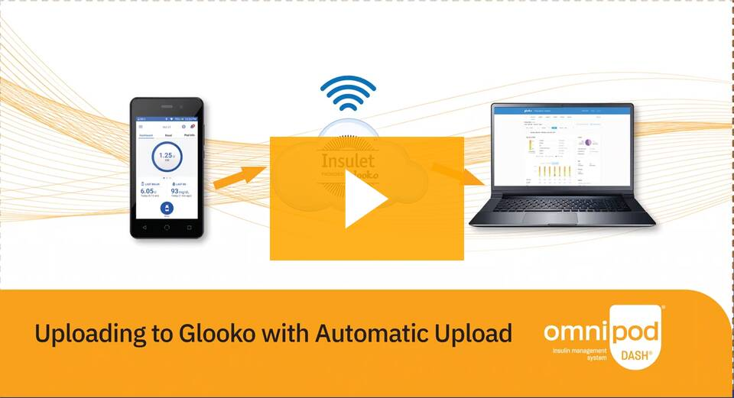](https://www.omnipod.com/current-podders/apps-software/glooko?wvideo=73ijq319lq)

[Insulet provided Glooko® | Omnipod](https://www.omnipod.com/current-podders/apps-software/glooko?wvideo=73ijq319lq)

**Setting up your Insulet (Omnipod) account**

If you need to create an account go to [www.omnipod.com/setup](http://www.omnipod.com/setup)

* You need to create and insulet ID
* Check your email for am email from Insulet/Omnipod inviting you to create an account
* Create or log into your Omnipod account to set up your ID
* If you have any issues please call insulet on 0800 011 6132
* You will need this ID at you pump start to set up your controller.



**Preparing for your pump start session**

**Dexcom G6**

Are you Continuous Glucose Monitoring (CGM) ready?

Before your pump start session you must be using the Dexcom G6 continuous glucose sensor with a mobile phone. If you are not using the sensor already and you do not have any Dexcom G6 supplies please contact the diabetes team.

You will still need a mobile phone to receive your G6 alarms and alerts and to have followers. Bring the phone you use for your Dexcom to the session with you.

**Pre Session Checklist**

Set up your Glooko Accountand link to MPFT

Create your Insulet ID

Watch the Omnipod 5 videos

Download the Omnipod 5 simulator and practice

Apple:

<https://apps.apple.com/gb/app/omnipod-5-simulator/id1552469689>

Android: <https://play.google.com/store/apps/details?id=com.insulet.stimulator&hl=en&gl=US>

Make sure you have 10ml vial of rapid acting insulin for your pump start session, take it out of the fridge before the session.

**Part Two**

**Setting up your pump and starting insulin**

Your new pump and initial supplies will be given to you at the pump start appointment.

Your new pump will be set up with you in your pump start session.

In preparation for your pump start session please write down the following information and bring with you on the day of your pump start, written records are easier to transfer;



* Current weight in kilograms (Kg)
* Current pump settings (if already pumping)
* Current background (basal) insulin dose (if using multiple daily injections (MDI) regimen)
* Current insulin/carbohydrate ratios
* Current insulin correction/sensitivity doses (referred to as ISF – insulin sensitivity factor)

You will also need the following;

* 10ml rapid acting insulin vial
* Average total daily dose of insulin – this is available via pump summary (if pumping) otherwise if MDI please use following calculation;

* Add background doses + **ALL** fast acting doses (bolus and corrections) for 7 days. Divide that figure by 7 = average daily dose of insulin. (referred to as TDD – Total Daily Dose)

If you currently use an insulin pump please ensure it has been uploaded to Glooko/Carelink at least 3 days prior to the Omnipod 5 pump start date.

***Prescription***

We have written to your GP to advise of the pump start and request the following items for your insulin pump start;

|  |  |
| --- | --- |
| **Item** | **X** |
| Rapid acting insulin (aspart (Novorapid) OR lispro (Humalog)) 100units/mL  ● 10 mL vials (for insulin pump) |  |

The following items should already be on your prescription. It is important that you have all of these items at home prior to starting insulin pump therapy. Please check the expiry date.

|  |  |
| --- | --- |
| **Item** | **X** |
| Long acting insulin (Insulin detemir, glargine or degludec), 100units/mL  ● 3mL penfill cartridges or prefilled pens (for use in emergency) |  |
| Rapid acting insulin (aspart (Novorapid) OR lispro (Humalog)) 100units/mL  ● 3mL penfill cartridges or prefilled pens (for use in emergency) |  |
| GlucoGen hypoKit (glucagon) |  |
| Blood ketone testing strips (compatible with your blood ketone meter) |  |
| Blood glucose testing strips (compatible with your blood glucose meter) |  |
| Lancets for the finger pricker |  |
| Needles for the insulin pen (4 or 5mm only) |  |
| Pen device / disposable pen for rapid acting insulin |  |
| Pen device / disposable pen for long acting insulin |  |
| Sharps container - PIP Code 402-8965 |  |

**Ordering your pump supplies**

Remember to order your ongoing pump supplies **after** your pump start from Insulet customer services.

**Your pump settings**

The settings for your new pump will be calculated by the diabetes team.

If you are moving from another pump or hybrid closed loop system the settings we give you may be different to the ones you have been using. Each pump/system works differently.

Your settings are designed to help you get the best possible results using the Omnipod 5.

If you are moving from injected insulin your insulin to carbohydrate ratios and sensitivity factor may also change.

**Reviewing your pump settings**

The automated basal (background) insulin is calculated from the total daily dose, changing the basal settings in your pump only effects your insulin delivery in manual mode. These settings will be reviewed at clinic.

Automated basal delivery can only be adjusted by changing the glucose target.

Carbohydrate ratios, Sensitivity factor and insulin on board time can be adjusted for bolus insulin delivery.

**Automated mode limited**

The system may revert to automated limited for 2 reasons:

If the CGM stops communicating with the pod for 20 minutes. If you lose connection between the pod and the sensor check your Dexcom app. If you have no readings on your Dexcom app you may have a sensor issue.

If an automated delivery restriction alarm occurs. This is caused by insulin being suspended or at max delivery for too long. The alarm must be cleared, after 5 minutes. Auto mode can be turned back on.

**Viewing data on Glooko**

There are 2 ways to look at your data on Glooko, you can view the data on the web page or create a PDF.

If you would like to learn more about looking at your downloads, please ask the diabetes team to support you with this.

**Pump Insurance**

Your pump has a manufacturer warranty which covers faults to the software or hardware. The warranty does not cover damage, loss or theft. If the pump handset is lost, stolen or is accidentally damaged, you will need insurance to replace it. The insulin pump handset is worth around £500 and could be mistaken for a phone.

If you have contents insurance, you can check with your provider to see if the insulin pump handset can be added, or you may want to look at separate pump insurance.

[Insurance for diabetes technology | JDRF](https://jdrf.org.uk/knowledge-support/managing-type-1-diabetes/guide-to-type-1-diabetes-technology/insurance-for-diabetes-technology/)

**\*\*\*Please note we have no information about this and are unable to recommend insurance companies/products\*\*\***