**Medtronic 780G system (+/- Medtronic Guardian sensor)**

**Workbook**

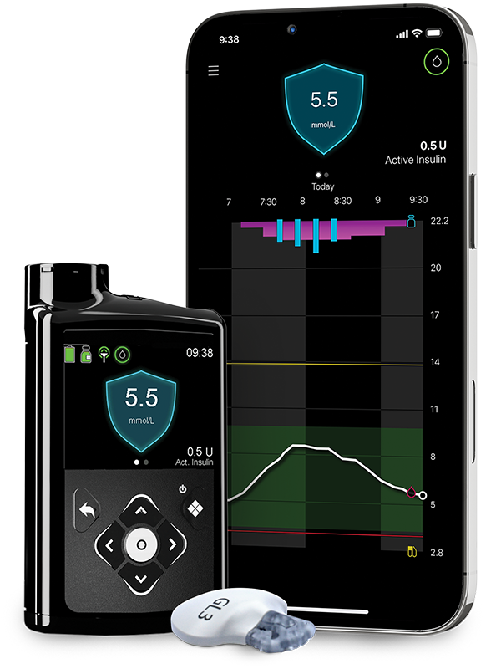

***This workbook is sent as a PDF so that you have access to the links.***

If you have problems viewing this PDF, get Adobe Acrobat Reader: PDF Viewer, Editor & Creator on your computer or phone/tablet.

1. **Android or tablet** , Install the free APP:- <https://play.google.com/store/apps/details?id=com.adobe.reader&hl=en_GB>

2. **iPhone or iPad**, install the free APP: <https://apps.apple.com/gb/app/adobe-reader/id469337564>

3. **Computer**: Install the free software: <https://get.adobe.com/uk/reader/otherversions/>

***Introduction:***

**How we are running our pump start sessions**

We have to make sure we provide training and support to enable you to safely start your insulin pump. We have developed a package with a combination of self directed learning, both reading and watching videos. You must complete this self-directed learning before you attend the pump start session with the MPFT diabetes team. There may be other patients wishing to start the same insulin pump at the same time and you will be in the session together. The session will be an opportunity to put into practice what you have learnt and to ask questions.

If you have not completed the tasks as instructed, you will not be allowed to carry on with the session and the pump start will be postponed. If you are having difficulty completing the self-directed learning or accessing the videos and other materials, please let us know as soon as possible so we can help with this.

Throughout the workbook there will be a series of videos, reading and tasks. We have used the following symbol to help identify the different tasks:

*The diabetes team at MPFT would like to thank University College Hospital London for sharing content used in this workbook.*

 A Task you need to complete

After you have started on your insulin pump, you will have regular follow up with the diabetes team. We advise that you are in your usual routine during, and for 6 weeks after your pump session i.e. avoid times when you know life is going to be busy or stressful (e.g.moving house, new job, holidays, exams).

**Please read the whole of the workbook and watch the videos before your pump start session.**

***Useful contact numbers and websites***

**Medtronic**

Customer service Tel: 01923 205167

Website to order supplies: [WeCare Login | Medtronic Diabetes (medtronic-diabetes.com)](https://www.medtronic-diabetes.com/en-gb/wecare/login)

**MPFT Diabetes Team**

Tel contact (office): 01889 527038

Email: [diabetes-south@mpft.nhs.uk](mailto:diabetes-south@mpft.nhs.uk)

Webpage: <https://www.mpft.nhs.uk/services/diabetes-services-adults>

**Part One**

This section of the workbook is the preparation for you to start on the new hybrid closed pump system.

***Expectations***

**What you can expect from the MPFT diabetes team:**

* We will provide you with the tools you need to move onto your new pump safely
* We will put you safety and wellbeing about everything else
* We will provide information and pre-course reading before your pump start
* We will ensure you have the correct equipment before your session
* We will ensure that the core values of MPFT are embedded in all consultations. These are: Putting people at the heart of what we do, Empowering people to improve care & wellbeing & Delivering better health, better care in partnership

**What MPFT diabetes team expects from you:**

* Complete the workbook before your pump start session.
* Join the session on time
* Complete all the post session parts of the workbook
* Follow all the instructions in the workbook
* Ask questions if you do not understand
* Collect prescription items from your GP prior to the pump start
* Do NOT put insulin into the pump and start using before the agreed time
* Create a carelink account to upload and share information with the team
* Contact Medtronic to deal with any technical issues

**System Use**

* Use the system in auto mode at least 90% of the time
* Wear sensors 90% of the time
* Aim to spend 70% of the time within the agreed target range, contact the team for advice if you are not reaching this goal between appointments.

***Understanding insulin pump therapy***

**What is insulin pump therapy?**

An insulin pump is an electronic devise that enables delivery of insulin throughout the day and night at adjustable doses to support management of diabetes. Please click on links below for more detailed information.

1. [https://www.nhs.uk/conditions/type-1-diabetes/managing-insulin/insulin-pumps**/**](https://www.nhs.uk/conditions/type-1-diabetes/managing-insulin/insulin-pumps/)
2. <https://www.diabetes.org.uk/guide-to-diabetes/managing-your-diabetes/treating-your-diabetes/insulin-pumps>
3. [Type 1 Technology & Resources - DigiBete](https://www.digibete.org/type-1-technology-resources/)

**What is Hybrid closed loop (HCL) pump therapy?**

Hybrid closed loop systems use and insulin pump and glucose sensor together to adjust insulin in response to glucose levels. A hybrid closed loop system can manage your glucose levels when you are sleeping, during the day you need to give bolus insulin for food and make adjustments to prevent low or high glucose levels with sports and activity. Watch the videos below about how HCL systems work;

<https://www.diabetes.org.uk/guide-to-diabetes/diabetes-technology/closed-loop-systems>

***Part A. Preparation - Before starting your pump session***

**Equipment, information and systems**

Make sure you have all the right equipment, information and systems is essential prior to starting your pump session.



* Set up a Carelink account [CareLink™ Personal Software – For People With Diabetes (minimed.eu)](https://carelink.minimed.eu/app/login)

For us to be able to view the data we ask that you share your username and password with us so we can link accounts

* Email username and password to = [diabetes-south@mpft.nhs.uk](mailto:diabetes-south@mpft.nhs.uk)
* Register for “WeCare “ support from Medtronic = [WeCare Login | Medtronic Diabetes (medtronic-diabetes.com)](https://www.medtronic-diabetes.com/en-gb/wecare/login)

***Using a mobile phone:***

If are NOT going to use a mobile phone, please skip this section.

You can view a list of compatible devices for the Minimed Mobile app (scroll down to the frequently asked questions at the bottom of the web page) = [MiniMed™ 780G system | Medtronic Diabetes (medtronic-diabetes.com)](https://www.medtronic-diabetes.com/en-gb/insulin-pump-therapy/minimed-780g-system#appCompatibility)



* Download the Minimed Mobile app onto your phone (use same username and password as Carelink TM account for the data to upload automatically). Do NOT pair to the pump at this stage.
* [MiniMed™ 780G system: MiniMed™ Mobile app - YouTube](https://www.youtube.com/watch?v=E6AAwofSzW8)
* OPTIONAL READING: <https://www.medtronicdiabetes.com/sites/default/files/library/download-library/user-guides/MiniMed-Mobile-App-User-Guide.pdf>

Care partners (followers) can download the Carelink Connect app to follow (you can have up to 5 care partners, each need to use a different username and password).



* [MiniMed™ 780G system: CareLink™ Connect app - YouTube](https://www.youtube.com/watch?v=s1Biwc9kl3s)
* You can view a list of compatible devices for the Minimed Mobile app (scroll down to the frequently asked questions at the bottom of the web page) = [MiniMed™ 780G system | Medtronic Diabetes (medtronic-diabetes.com)](https://www.medtronic-diabetes.com/en-gb/insulin-pump-therapy/minimed-780g-system#appCompatibility)

***NOT using a mobile phone:***

You will need to install the Medtronic Uploader onto your computer.



* [Installing and Using the CareLink Uploader | Medtronic Diabetes](https://www.medtronicdiabetes.com/customer-support/carelink-software-support/installing-and-uploading)

In order to upload the pump you will need the Medtronic BLUE dongle (you should have received this with the pump)

**\*\*If you have problems setting up an account or installing the uploader please contact Medtronic customer support\*\***

***Pump Belt/Pouch***

The pump comes with a belt clip (in accessories pack) however you may consider a more secure way of carrying the pump, such as a pump belt, Spibelt or pouch. You can also buy screen protectors. Known suppliers of such consumables are (other suppliers available);

[Online Shop for All Diabetes Needs. Myabetic and Other Brands. (diabeticsupply.co.uk)](https://www.diabeticsupply.co.uk/)

[Diabetes Equipment – Insulin Pump Pouches / Holders – Official Diabetes Equipment Suppliers – Official Spibelt, Frio Wallet and Jelly Belly stockists. (funkypumpers.com)](https://www.funkypumpers.com/)

[Spibelt running belt with expandable pocket-fits iPhone 11, gels,keys – spibelt-running-belts](https://www.spibelt.co.uk/)

[Accessories | Making Diabetes Easier](https://www.makingdiabeteseasier.com/uk/products-and-support/accessories)

***Insurance***

Your pump has a manufacturer warranty for 4 years. This covers faults to the software or hardware. The warranty does not cover damage, loss or theft. The insulin pump is worth around £3000. For this reason we recommend that you insure the pump. If the pump is lost, stolen or is accidentally damaged, you will need insurance to replace it.

If you have contents insurance, you can check with your provider to see if the insulin pump can be added, or you may want to look at separate pump insurance.

[Insurance for diabetes technology | JDRF](https://jdrf.org.uk/knowledge-support/managing-type-1-diabetes/guide-to-type-1-diabetes-technology/insurance-for-diabetes-technology/)

**\*\*\*Please note we have no information about this and are unable to recommend insurance companies/products\*\*\***

***Prescription***

We have written to your GP to advise of the pump start and request the following items for your insulin pump start;

|  |  |
| --- | --- |
| **Item** | **X** |
| Rapid acting insulin (aspart (Novorapid) OR lispro (Humalog)) 100units/mL  ● 10 mL vials (for insulin pump) |  |

The following items should already be on your prescription. It is important that you have all of these items at home prior to starting insulin pump therapy. Please check the expiry date.

|  |  |
| --- | --- |
| **Item** | **X** |
| Long acting insulin (Insulin detemir, glargine or degludec), 100units/mL  ● 3mL penfill cartridges or prefilled pens (for use in emergency) |  |
| Rapid acting insulin (aspart (Novorapid) OR lispro (Humalog)) 100units/mL  ● 3mL penfill cartridges or prefilled pens (for use in emergency) |  |
| GlucoGen hypoKit (glucagon) |  |
| Blood ketone testing strips (compatible with your blood ketone meter) |  |
| Blood glucose testing strips (compatible with your blood glucose meter) |  |
| Lancets for the finger pricker |  |
| Needles for the insulin pen (4 or 5mm only) |  |
| Pen device / disposable pen for rapid acting insulin |  |
| Pen device / disposable pen for long acting insulin |  |
| Sharps container - PIP Code 402-8965 |  |



* Check your repeat prescriptions to ensure you have prescribed the items that you need.

***Continuous Glucose monitoring***

You will need to use the Guardian transmitter and sensor if you are going to use SmartGuard technology (hybrid closed loop system). If you are not going to be using continuous glucose monitoring (sensors) you can skip this section and move onto Part B.

If you are going to be using the Guardian transmitter and sensors, instructions for when to insert, will be given in Part B.

If you are new to the Guardian sensor, you will need to watch the following video in preparation for part B.



* [How to insert the Guardian™ 4 Sensor on the abdomen - YouTube](https://www.youtube.com/watch?v=ZhxOpF_Y3ac)
* [How to insert the Guardian™ 4 Sensor on the back of the arm - YouTube](https://www.youtube.com/watch?v=c68NUqblf4k)
* Charge the Guardian transmitter fully (do not leave the transmitter in the charger once fully charged).
* The GuardianTM transmitter user guide can be found here [Guardian-Link-3-Transmitter-User-Guide.pdf (medtronicdiabetes.com)](https://www.medtronicdiabetes.com/sites/default/files/library/download-library/user-guides/Guardian-Link-3-Transmitter-User-Guide.pdf)

***Part B. Learning about your insulin pump***

Please work through Part B in preparation for your pump start session. You can watch the videos at any time and as many times as you like and you will have these links to use for future reference.



* [Expert Opinions: Medtronic Minimed 780G | The Association of British Clinical Diabetologists (abcd.care)](https://abcd.care/resource/expert-opinions-medtronic-minimed-780g)
* [New Medtronic MiniMed™ 780G Insulin Pump system - YouTube](https://www.youtube.com/watch?v=4n4u5PdxYfA)
* [MiniMed™ Mio™ Advance infusion set – how to use it - YouTube](https://www.youtube.com/watch?v=2For6SAvxRQ)
* [How to insert the Medtronic MiniMed Sure-T infusion set - diabetes therapy - YouTube](https://www.youtube.com/watch?v=pTXEqEUhZ_Q)

***Getting to Know Your Pump***

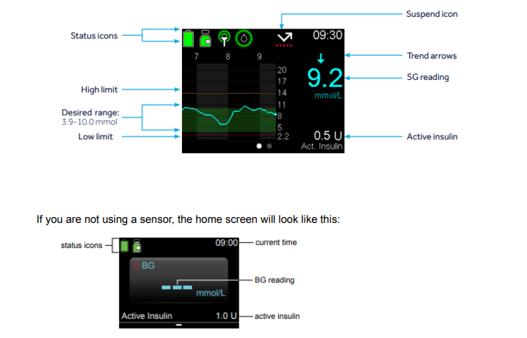

Familiarise yourself with this menu

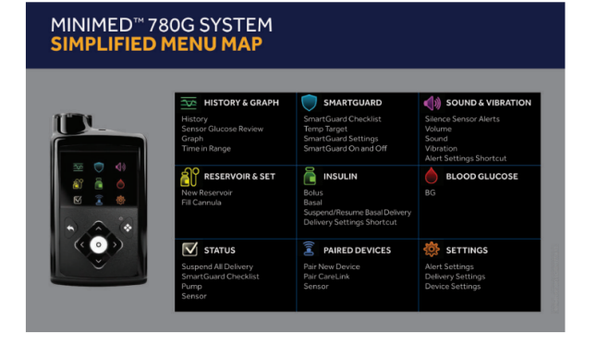

***Pairing Devices***



* Pair your blood glucose meter to the pump = [{68c6b853-54e4-43f4-b149-7ca427415f02}_UC202113698_EE__MM780G_Get_Connected_Pair_Meter_and_Tran_One_Pager_v2.pdf (mdtpatient.com)](https://images.medtronicdib.mdtpatient.com/Web/MedtronicDIB/%7B68c6b853-54e4-43f4-b149-7ca427415f02%7D_UC202113698_EE__MM780G_Get_Connected_Pair_Meter_and_Tran_One_Pager_v2.pdf)
* Pair your Minimed Mobile app to the pump = [MiniMed™ 780G system: MiniMed™ Mobile app - YouTube](https://www.youtube.com/watch?v=E6AAwofSzW8)
* Pair your Guardian™ Link transmitter to the pump = [{68c6b853-54e4-43f4-b149-7ca427415f02}_UC202113698_EE__MM780G_Get_Connected_Pair_Meter_and_Tran_One_Pager_v2.pdf (mdtpatient.com)](https://images.medtronicdib.mdtpatient.com/Web/MedtronicDIB/%7B68c6b853-54e4-43f4-b149-7ca427415f02%7D_UC202113698_EE__MM780G_Get_Connected_Pair_Meter_and_Tran_One_Pager_v2.pdf)

You can check that the devices are paired in the Paired Devices menu

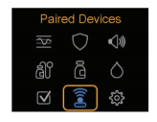

***Device Settings***



Go to 'Settings' and the 'Device Settings'. Here you can;

* change the date/time.
* If you are using the GuardianTM sensor, you will also need to switch ‘sensor’ ON
* Go to ‘Display’ to adjust the brightness and backlight (optional)

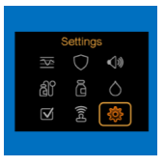

***Delivery Settings***

Select 'Insulin' menu and the 'Delivery Settings' (you can also access this via the ‘Settings’ menu)

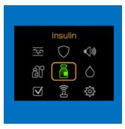

***Cannulas / infusion sets / Sensors***

Please watch the following video in preparation for your pump start



* [MiniMed™ Mio™ Advance infusion set – how to use it - YouTube](https://www.youtube.com/watch?v=2For6SAvxRQ)
* How to insert the Medtronic MiniMed Sure-T infusion set - diabetes therapy – YouTube
* [How to insert the Guardian™ 4 Sensor on the abdomen - YouTube](https://www.youtube.com/watch?v=ZhxOpF_Y3ac)
* [How to insert the Guardian™ 4 Sensor on the back of the arm - YouTube](https://www.youtube.com/watch?v=c68NUqblf4k)

***Understanding Exercise***



* [DIFFERENT TYPES OF EXERCISE EXPLAINED (wistia.com)](https://hma.wistia.com/medias/5knd8w44ml)
* [A GUIDE TO EXERCISE WITH TYPE 1 DIABETES (wistia.com)](https://hma.wistia.com/medias/gyfn38xrvy)
* [TOP TIPS FOR EXERCISE MANAGEMENT (wistia.com)](https://hma.wistia.com/medias/ts1s4epvmn)

***Where to place your cannula:***



You can wear your cannula on the upper buttocks, abdomen and legs.

The cannula must be 3 inches away from the sensor/transmitter and they must be in direct line of sight.

***Cannula Changes***

You need to change the cannula every 2-3 days.

Do **NOT** change you cannula at night / just before bed. You need to be able to check your glucose levels for 2-3 hours after your cannula change. The ideal time to change is before a meal, as it will quickly become noticeable if there is an issue with the cannula.

***Staying safe on Insulin Pump Therapy***

X:\Diabetes MPFT\Master\Pump\Pumps 2022 onwards\Sick Day Rules - Pump\MFPT Sick Day Rules for Insulin Pump Users.docx



***Highs, Lows and Sick day rules:***

You will still need to manage some high and low glucose levels using your HCL system. This will be different to how you manage highs and lows sick days on injections or on a manual pump.

It is important to know how to manage highs and lows and sick days to stay safe.

Hypo treatments on HCL systems should be no more than 10g carbohydrate. Big hypo treatments can cause rebound hyperglycaemia. Always wait 15 minutes before re-treating to give the glucose time to rise.

Remember if the glucose levels are 14mmol/l or more for more than 90 minutes check for blood ketones. If your level is 14mmol/l or more and you feel unwell check for ketones don’t wait.

***Hyperglycaemia:***

**Managing High Glucose levels – Hybrid Closed loop systems.**

If glucose is 14mmol/L or above check for blood ketones.

* If ketones are below 0.6mmol/L- follow ADCC (below)
* If Ketones are 0.6mmol/L or above follow sick day rules (below)

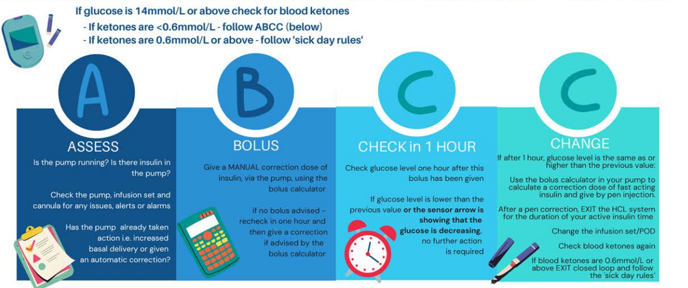

You should make standard checks on the pump for blockages (occlusions), disconnection and battery failures.

Give correction doses through the pump if blood ketone levels are less than 0.6mmol/L.

**Glucose levels less than 5.5mmol/l**

|  |  |  |
| --- | --- | --- |
| If not tolerating drinks/fluids – go to local A&E | | |
| **Blood Ketones** | **Action** | **Additional Action** |
| |  | | --- | |  |   Less than 0.6 mmol/L | *Treat hypo as usual   |  | | --- | |  | | *If experiencing recurrent hypos, set decreased temporary basal for 2 hours (50% or -50%) |
| 0.6 - 1.4 mmol/L | |  | | --- | | *Take 20g carbohydrate and clear fluids containing sugar  *Recheck blood glucose and ketones in 2 hours | |
| |  | | --- | |  |   1.5 - 2.9 mmol/L | |  | | --- | | *Take 20g carbohydrate  and clear fluids containing sugar    *Check blood glucose and ketones after 2 hours  *Repeat above steps again.  *If remains unchanged after 4 hours, then seek urgent advice | |
| More than 3.0 mmol/L | *As above  *If concerned Call Diabetes Team for urgent advice / Go to A&E |

**Glucose levels greater than 14mmol/l**

|  |  |  |
| --- | --- | --- |
| If not tolerating drinks/fluids – go to local A&E | | |
| **Blood Ketones** | **Action** | **Additional Action** |
| |  | | --- | |  |   Less than 0.6 mmol/L | *Calculate correction dose using pump calculator.  *Give advised correction via pump  *Recheck in 4 hours   |  | | --- | |  | | *No additional action |
| 0.6 - 1.4 mmol/L | *Look at suggested pump correction  *Increase correction dose by 50% & give additional correction via insulin pen.  *Change pump cannula/set/troubleshoot  *Increase fluids (>100ml/hr)  *Recheck in 2 hours | *Program temporary basal rate for 2 hours @ +10-20% |
| |  | | --- | |  |   1.5 - 2.9 mmol/L | *Look at suggested pump correction  *Double correction dose and give additional correction via insulin pen.  *Change pump cannula/set/troubleshoot  *Increase fluids (>100ml/hr)  *Recheck in 2 hours | *Program temporary basal rate for 2 hours @ +30% |
| More than 3.0 mmol/L | *As above  *Recheck in 2 hours  *Call Diabetes Team for advice – You may need to go to A & E | *Program temporary basal rate for 2 hours @ +50% |

***What to do if your pump breaks***

**Process of pump replacement (Medtronic):**



• In the event of a pump failure call customer services

• Customer services will try to troubleshoot any issues that have occurred

• If customer services are unable to solve the issue then your pump will be replaced with a new pump

**When would my pump warranty not cover a free replacement pump?**

The pumps have a 4 year warranty from the date they were given to you. However, the warranty may not apply:

1. If damage results from changes or modifications made to the system by the user or third persons after the date of manufacture

2. If damage results from service or repairs performed by any person or entity other than the appropriate pump company

**Should I contact my diabetes team?**

Once you have spoken to your pump company, you will know whether your pump needs to be replaced. If it does need to be replaced you will need to think about how you will get insulin until the new pump is delivered. Check what both the blood glucose and blood ketones are, as this will determine what you need to do next. The pump company will not be able to give you any clinical advice so you may want to ring the diabetes team for advice.

***Part C – Next Steps***

In preparation for your pump start session please write down the following information and bring with you on the day of your pump start, written records are easier to transfer;



* Current weight in kilograms (Kg)
* Current pump settings (if already pumping)
* Current background (basal) insulin dose (if using multiple daily injections (MDI) regimen)
* Current insulin/carbohydrate ratios
* Current insulin correction/sensitivity doses (referred to as ISF – insulin sensitivity factor)

You will also need the following;

* 10ml rapid acting insulin vial
* Average total daily dose of insulin – this is available via pump summary (if pumping) otherwise if MDI please use following calculation;

* Add background doses + **ALL** fast acting doses (bolus and corrections) for 7 days. Divide that figure by 7 = average daily dose of insulin. (referred to as TDD – Total Daily Dose)

If you currently use an insulin pump please ensure it has been uploaded to Glooko/Carelink at least 3 days prior to the pump start date.