***YpsoPump® Insulin Pump Workbook***

***mylife Cam APS FX***

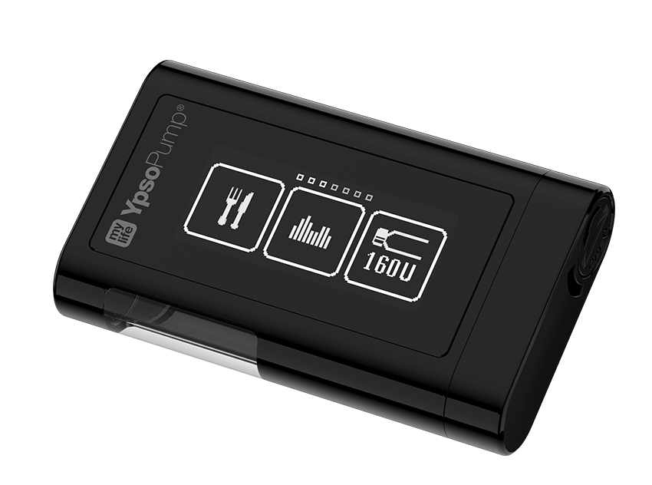

***This workbook is sent as a PDF so that you have access to the links.***

If you have problems viewing this PDF, get Adobe Acrobat Reader: PDF Viewer, Editor & Creator on your computer or phone/tablet.

1. **Android or tablet** , Install the free APP:- <https://play.google.com/store/apps/details?id=com.adobe.reader&hl=en_GB>

2. **iPhone or iPad**, install the free APP: <https://apps.apple.com/gb/app/adobe-reader/id469337564>

3. **Computer**: Install the free software: <https://get.adobe.com/uk/reader/otherversions/>

***Introduction:***

**How we are running our pump start sessions**

We have to make sure we provide training and support to enable you to safely start your insulin pump. We have developed a package with a combination of self directed learning, both reading and watching videos. You must complete this self-directed learning before you attend the pump start session with the MPFT diabetes team. There may be other patients wishing to start the same insulin pump at the same time and you will be in the session together. The session will be an opportunity to put into practice what you have learnt and to ask questions.

If you have not completed the tasks as instructed, you will not be allowed to carry on with the session and the pump start will be postponed. If you are having difficulty completing the self-directed learning or accessing the videos and other materials, please let us know as soon as possible so we can help with this.

Throughout the workbook there will be a series of videos, reading and tasks. We have used the following symbol to help identify the different tasks:

*The diabetes team at MPFT would like to thank University College Hospital London for sharing content used in this workbook.*

 A Task you need to complete

After you have started on your insulin pump, you will have regular follow up with the diabetes team. We advise that at the time of each follow up and for 6 weeks after your pump session you are in your usual routine, i.e. avoid times when you know life is going to be busy or stressful (e.g.moving house, new job, holidays, exams).

*\*\*Settings in your YpsoPump® hybrid closed loop system (HCL) will be different to those you have used with standard insulin pump therapy. Your settings will be reviewed before you start on your new pump\*\**

**Please read the whole of the workbook and watch the videos before your pump start session.**

***Useful contact numbers and websites***

**Dexcom**

Technical Support Tel: 0800 031 5763 Mon-Fri 07:00hrs-18:00hrs. Sat-Sun 08:30hrs-16:30hrs

Dexcom replacement sensors online [www.dexcom.com/UKIETechsupport](http://www.dexcom.com/UKIETechsupport)

Dexcom customer services Tel: 0800 031 5761

**YpsoPump**

Customer service Tel: 0344 8567820

Email: info@ypsopump.co.uk

**Glooko**

Tel contact: 0207 795 8191

Email: [support@glooko.com](mailto:support@glooko.com)

**MPFT Diabetes Team**

Tel contact (office): 01889 527038

Email: [diabetes-south@mpft.nhs.uk](mailto:diabetes-south@mpft.nhs.uk)

Webpage: <https://www.mpft.nhs.uk/services/diabetes-services-adults>

*If you have any issues with your mylife CamAPS FX app you should contact YpsoPump for support*

**Part One**

This section of the workbook is the preparation for you to start on the new hybrid closed pump system.

***Aims***

By the end of pump upgrade we aim for you to:

* Be able to use the YpsoPump and CamAPS FX safely and effectively
* Be able to download your pump, understand the reports and think about what changes might be needed

***Expectations***

**What you can expect from the MPFT diabetes team:**

* We will provide you with the tools you need to move onto your new pump safely
* We will put your safety and wellbeing above everything else
* We will provide information and pre-course reading before your pump start session
* We will ensure you have the correct equipment before your session
* We will ensure that the core values of MPFT are embedded in all consultations. These are: Putting people at the heart of what we do, Empowering people to improve care & wellbeing & Delivering better health, better care in partnership.

**What MPFT diabetes team expects from you:**

* Complete the workbook before your pump start session.
* Attend the session on time
* Follow all the instructions in the workbook
* Ask questions if you do not understand
* Collect prescription items from your GP prior to the pump start session
* Do **NOT** put insulin into the pump and start using before the agreed time
* Create a Glooko account to upload and share information with the team
* Contact Dexcom or Ypsopump to deal with any technical issues
* Attend follow up clinic appointments regularly.

**System Use**

* Use the system in HCL mode at least 90% of the time
* Wear sensors 90% of the time
* Aim to spend 70% of the time within the agreed target range, contact the team for advice if you are not reaching this goal between appointments.

***Understanding insulin pump therapy***

**What is insulin pump therapy?**

An insulin pump is an electronic device that enables delivery of insulin throughout the day and night at adjustable doses to support management of diabetes. Please click on links below for more detailed information.

1. [https://www.nhs.uk/conditions/type-1-diabetes/managing-insulin/insulin-pumps**/**](https://www.nhs.uk/conditions/type-1-diabetes/managing-insulin/insulin-pumps/)
2. <https://www.diabetes.org.uk/guide-to-diabetes/managing-your-diabetes/treating-your-diabetes/insulin-pumps>
3. [Type 1 Technology & Resources - DigiBete](https://www.digibete.org/type-1-technology-resources/)

**What is Hybrid closed loop (HCL) pump therapy?**

Hybrid closed loop systems use an insulin pump and glucose sensor together to adjust insulin doses in response to glucose levels. A hybrid closed loop system can manage your glucose levels when you are sleeping, however, during the day you need to give bolus insulin for food and make adjustments to prevent low or high glucose levels with sports and activity.

Watch the video below about how HCL systems work;

<https://www.diabetes.org.uk/guide-to-diabetes/diabetes-technology/closed-loop-systems>

***Part A. Preparation - Before starting your pump session*** 

**Equipment, information and systems**

It is essential that you have all the right equipment, information and systems prior to starting your pump session.

1. If you are using CamAPS you will need a compatible Android smartphone, the system does not yet work with IOS devices. You can see a list of compatible devices here;

<https://www.dexcom.com/compatibility>

1. Ensure you have downloaded the YpsoPump Explorer app. This is needed to practice using menus and to watch ‘how to’ videos;

[YpsoPump Explorer App - mylife Diabetescare – United Kingdom (mylife-diabetescare.com)](https://www.mylife-diabetescare.com/en-GB/products/infusion-systems/mylife-ypsopump-insulin-pump/ypsopump-explorer-landing-page.html)

1. Download mylife CamAPS FX app (android only);

[mylife CamAPS FX (mmol/L) - Apps on Google Play](https://play.google.com/store/apps/details?id=com.camdiab.fx_alert.mmoll&hl=en&gl=US)

1. Set up a Glooko account. If already using a pump please check with your diabetes team as the accounts may already be active.

[LogbookWeb (glooko.com)](https://my.glooko.com/users/sign_in)

1. Share your Glooko account with the MPFT Diabetes team. The MPFT Proconnect clinic code is = **Enmpftcommunity**

***Dexcom Follow***

The mylife CamAPS FX app is the receiver for the Dexcom G6. You also start and stop the sensor in the mylife CamAPS FX app. You will not be able to use the Dexcom G6 app alongside the mylife CamAPS FX app. Therefore you cannot use the Dexcom Follow app.

If you wish to be able to use the ‘follow’ function, download the Glooko app as this can be used to “follow” the sensor data. The Glooko app works with both android and IOS systems.

**\*\*If you have problems setting up an account or sharing data please contact Glooko\*\***

***Pump Belt/Pouch***

The pump comes with a belt clip (in accessories pack) however you may consider a more secure way of carrying the pump, such as a pump belt, Spibelt or pouch. You can also buy screen protectors. Suppliers of such consumables used by other patients are shared below (\**other suppliers available*);

[Online Shop for All Diabetes Needs. Myabetic and Other Brands. (diabeticsupply.co.uk)](https://www.diabeticsupply.co.uk/)

[Diabetes Equipment – Insulin Pump Pouches / Holders – Official Diabetes Equipment Suppliers – Official Spibelt, Frio Wallet and Jelly Belly stockists. (funkypumpers.com)](https://www.funkypumpers.com/)

[Spibelt running belt with expandable pocket-fits iPhone 11, gels,keys – spibelt-running-belts](https://www.spibelt.co.uk/)

[Accessories | Making Diabetes Easier](https://www.makingdiabeteseasier.com/uk/products-and-support/accessories)

***Insurance***

Your pump has a manufacturer warranty for 4 years. This covers faults to the software or hardware. The warranty does not cover damage, loss or theft. The insulin pump is worth around £3000. For this reason we recommend that you insure the pump. If the pump is lost, stolen or is accidentally damaged, you will need insurance to replace it.

If you have contents insurance, you can check with your provider to see if the insulin pump can be added, or you may want to look at separate pump insurance.

[Insurance for diabetes technology | JDRF](https://jdrf.org.uk/knowledge-support/managing-type-1-diabetes/guide-to-type-1-diabetes-technology/insurance-for-diabetes-technology/)

**\*\*\*Please note we have no information about this and are unable to recommend insurance companies/products\*\*\***

***Prescription***

We have written to your GP to advise of the pump start and request the following items for your insulin pump start;

|  |  |
| --- | --- |
| **Item** | **X** |
| Rapid acting insulin (aspart (Novorapid) OR lispro (Humalog)) 100units/mL  ● 10 mL vials (for insulin pump) |  |

The following items should already be on your prescription. It is important that you have all of these items at home prior to starting insulin pump therapy. Please check the expiry date.

|  |  |
| --- | --- |
| **Item** | **X** |
| Long acting insulin (Insulin detemir, glargine or degludec), 100units/mL  ● 3mL penfill cartridges or prefilled pens (for use in emergency) |  |
| Rapid acting insulin (aspart (Novorapid) OR lispro (Humalog)) 100units/mL  ● 3mL penfill cartridges or prefilled pens (for use in emergency) |  |
| GlucoGen hypoKit (glucagon) |  |
| Blood ketone testing strips (compatible with your blood ketone meter) |  |
| Blood glucose testing strips (compatible with your blood glucose meter) |  |
| Lancets for the finger pricker |  |
| Needles for the insulin pen (4 or 5mm only) |  |
| Pen device / disposable pen for rapid acting insulin |  |
| Pen device / disposable pen for long acting insulin |  |
| Sharps container - PIP Code 402-8965 |  |



* Check your repeat prescriptions to ensure you have the prescribed items that you need.
* Remember to order your ongoing pump supplies after your pump start from YpsoPump customer services.

***Continuous Glucose monitoring***

You will need to use the Dexcom G6 transmitter and sensor if you are going to use CamAPS FX (hybrid closed loop system). If you are not going to be using Dexcom G6 you can skip this section and move onto Part B. If you are new to the Dexcom G6, complete the whole of the Dexcom G6 tutorial before your pump upgrade. If you are already using Dexcom G6 we ask you to complete the features and conclusion sections of the training as a refresher.



* [Dexcom G6 - what is Continuous Glucose Monitoring (CGM), diabetes & more. | Dexcom](https://www.dexcom.com/en-gb/dexcom-g6-learn-the-basics)
* Complete the tutorial = [Dexcom G6 Training Tutorial](https://s3-us-west-2.amazonaws.com/dexcomvideos/G6+OUS+App+Videos/UK/LBL015873+Dexcom+G6+OUS+Tutorial+mmol/story_html5.html)
* [LBL017585+-+Dexcom+G6+-+Training+Checklist+Final.pdf](https://s3-us-west-2.amazonaws.com/dexcompdf/OUS+Specific+PDFs/UK+G6+Training+Deck/LBL017585+-+Dexcom+G6+-+Training+Checklist+Final.pdf)

Here are our recommended settings for starting Dexcom with the CamAPS FX app. You can change these at any time depending on what you find most helpful;

• Urgent Low Soon = On

• Low Alert = 3.6 mmol/L

• High Alert = 14.0 mmol/L

• High Repeat = 90 minutes

• Signal loss = 20 minutes

*The mylife CamAPS FX app is the receiver for the Dexcom G6. You also start and stop the sensor in the mylife CamAPS FX app. You will not be able to use the Dexcom G6 app alongside the mylife CamAPS FX app (refer to Page 6).*

***Dexcom G6 sensor placement consideration***

• Areas for insertion of Dexcom G6 in adults include the abdomen (stomach) and upper arm for adults.

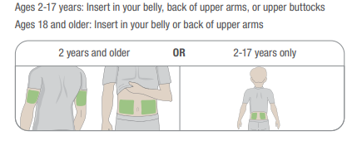

***Part B. Learning about your insulin pump***

Please work through Part B in preparation for your pump start session. You can watch the videos at any time and as many times as you like and you will have these links to use for future reference.



* [Expert Opinions: Ypso Pump | The Association of British Clinical Diabetologists (abcd.care)](https://abcd.care/resource/expert-opinions-ypso-pump)

***Learning about CamAPS FX***

To access the mylife CamAPS FX hybrid closed loop you will need to complete their training modules. Once completed you will receive a code which allows you access to the CamAPS FX app (android only).



* Log into your CamDiab account and complete the Essential CamAPS FX training for People living with Type 1 diabetes. It takes approximately 45 - 60 minutes to complete. Once you have completed the training evaluation, you will receive your unique code which unlocks the app. You can find this on your certificate.

***Learning about YpsoPump***



* Using the YpsoPump Explorer app, Select the menu → Start app tutorial → to familiarise yourself with the pump

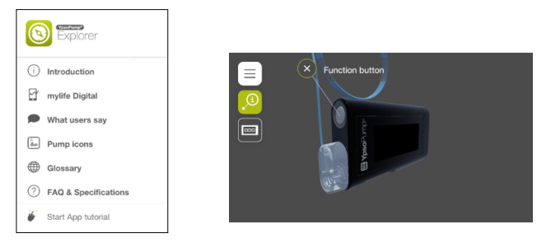

* Select the menu → Guided Tours → Navigation → Play

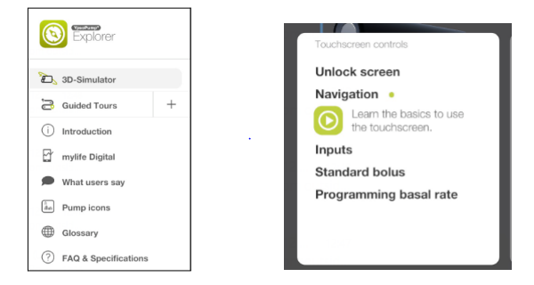

* Using the YpsoPump Explorer app, familiarise yourself with the pump icons

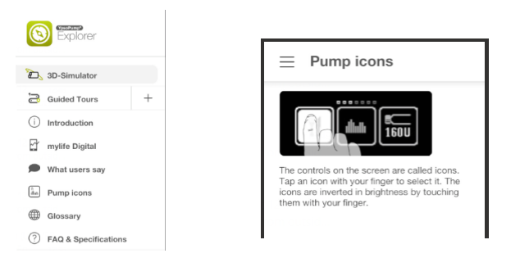

***Setting up your YpsoPump***

DO NOT put insulin into the pump DO NOT set up the infusion set DO NOT attach the insulin pump to the body



* [Handling videos - mylife Diabetescare – United Kingdom (mylife-diabetescare.com)](https://www.mylife-diabetescare.com/en-GB/services/handling-videos.html)

***Where to place your pump cannula:***

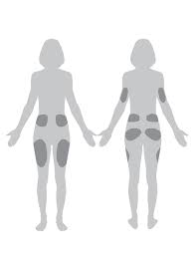

You can wear your cannula on the upper buttocks, abdomen and legs.

The cannula must be 3 inches away from the sensor/transmitter and they must be in direct line of sight.

***Cannula Changes***

You need to change the cannula every 2-3 days.

Do **NOT** change you cannula at night / just before bed. You need to be able to check your glucose levels for 2-3 hours after your cannula change. The ideal time to change is before a meal, as it will quickly become noticeable if there is an issue with the cannula.

***Staying safe on Insulin Pump Therapy***

X:\Diabetes MPFT\Master\Pump\Pumps 2022 onwards\Sick Day Rules - Pump\MFPT Sick Day Rules for Insulin Pump Users.docx



***Highs, Lows and Sick day rules:***

You will still need to manage some high and low glucose levels using your HCL system. This will be different to how you manage highs and lows sick days on injections or on a manual pump.

It is important to know how to manage highs and lows and sick days to stay safe.

Hypo treatments on HCL systems should be no more than 10g carbohydrate. Big hypo treatments can cause rebound hyperglycaemia. Always wait 15 minutes before re-treating to give the glucose time to rise.

Remember if the glucose levels are 14mmol/L or more for more than 90 minutes, check for blood ketones. If your level is 14mmol/L or more and you feel unwell, check for ketones don’t wait.

***Hyperglycaemia:***

**Managing High Glucose levels – Hybrid Closed loop systems.**

If glucose is 14mmol/L or above check for blood ketones.

* If ketones are below 0.6mmol/L- follow ADCC (below)
* If ketones are 0.6mmol/L or above follow sick day rules (below)

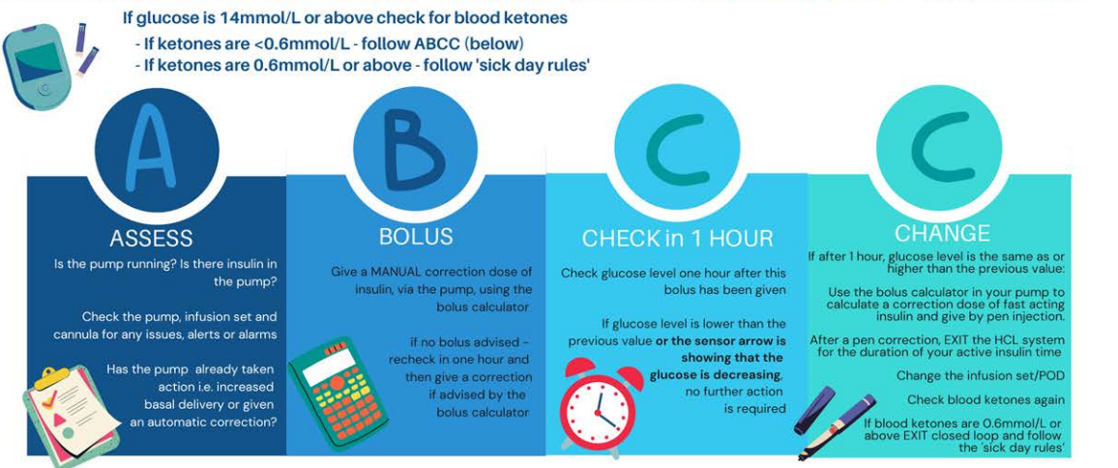

You should make standard checks on the pump for blockages (occlusions), disconnection and battery failures.

Give correction doses through the pump if blood ketone levels are less than 0.6mmol/L.

**Glucose levels less than 5.5mmol/l**

|  |  |  |
| --- | --- | --- |
| If not tolerating drinks/fluids – go to local A&E | | |
| **Blood Ketones** | **Action** | **Additional Action** |
| |  | | --- | |  |   Less than 0.6 mmol/L | *Treat hypo as usual   |  | | --- | |  | | *If experiencing recurrent hypos, set decreased temporary basal for 2 hours (50% or -50%) |
| 0.6 - 1.4 mmol/L | |  | | --- | | *Take 20g carbohydrate and clear fluids containing sugar  *Recheck blood glucose and ketones in 2 hours | |
| |  | | --- | |  |   1.5 - 2.9 mmol/L | |  | | --- | | *Take 20g carbohydrate  and clear fluids containing sugar    *Check blood glucose and ketones after 2 hours  *Repeat above steps again.  *If remains unchanged after 4 hours, then seek urgent advice | |
| More than 3.0 mmol/L | *As above  *If concerned Call Diabetes Team for urgent advice / Go to A&E |

**Glucose levels greater than 14mmol/l**

|  |  |  |
| --- | --- | --- |
| If not tolerating drinks/fluids – go to local A&E | | |
| **Blood Ketones** | **Action** | **Additional Action** |
| |  | | --- | |  |   Less than 0.6 mmol/L | *Calculate correction dose using pump calculator.  *Give advised correction via pump  *Recheck in 4 hours   |  | | --- | |  | | *No additional action |
| 0.6 - 1.4 mmol/L | *Look at suggested pump correction  *Increase correction dose by 50% & give additional correction via insulin pen.  *Change pump cannula/set/troubleshoot  *Increase fluids (>100ml/hr)  *Recheck in 2 hours | *Program temporary basal rate for 2 hours @ +10-20% |
| |  | | --- | |  |   1.5 - 2.9 mmol/L | *Look at suggested pump correction  *Double correction dose and give additional correction via insulin pen.  *Change pump cannula/set/troubleshoot  *Increase fluids (>100ml/hr)  *Recheck in 2 hours | *Program temporary basal rate for 2 hours @ +30% |
| More than 3.0 mmol/L | *As above  *Recheck in 2 hours  *Call Diabetes Team for advice – You may need to go to A & E | *Program temporary basal rate for 2 hours @ +50% |

***What to do if your pump breaks***

**Process of pump replacement:**



In the event of a pump failure call YpsoPump customer services, they will try to troubleshoot any issues that have occurred. If customer services are unable to resolve the issue, then they will replace your pump.

**When would my pump warranty not cover a free replacement pump?**

The YpsoPump has a 4 year warranty from the date they were given to you. However, the warranty may not apply:

* If damage results from changes or modifications made to the system by the user or third persons after the date of manufacture.
* If damage results from service or repairs performed by any person or entity other than the appropriate pump company.
* Accidental damage.

**Should I contact my diabetes team?**

Once you have spoken to your pump company, you will know whether your pump needs to be replaced. If it does need to be replaced you will need to think about how you will get insulin until the new pump is delivered. Check what both the blood glucose and blood ketones are, as this will determine what you need to do next. The pump company will not be able to give you any clinical advice so you may want to ring the diabetes team for advice.

***Part C – Next Steps***

In preparation for your pump start session please write down the following information and bring with you on the day of your pump start, written records are easier to transfer;



* Current weight in kilograms (Kg)
* Current pump settings (if already pumping)
* Current background (basal) insulin dose (if using multiple daily injections (MDI) regimen)
* Current insulin/carbohydrate ratios
* Current insulin correction/sensitivity doses (referred to as ISF – insulin sensitivity factor)

You will also need the following;

* 10ml rapid acting insulin vial
* Average total daily dose of insulin – this is available via pump summary (if pumping) otherwise if MDI please use following calculation;

* Add background doses + **ALL** fast acting doses (bolus and corrections) for 7 days. Divide that figure by 7 = average daily dose of insulin. (referred to as TDD – Total Daily Dose)

If you currently use an insulin pump please ensure it has been uploaded to Glooko/Carelink at least 3 days prior to the pump start date.

***Part D***

***Understanding Exercise/Physical Activity***

These videos are an overview of exercise and diabetes. There is also a webinar on managing exercise with CamAPS FX on the CamDiab platform.



* [DIFFERENT TYPES OF EXERCISE EXPLAINED (wistia.com)](https://hma.wistia.com/medias/5knd8w44ml)
* [A GUIDE TO EXERCISE WITH TYPE 1 DIABETES (wistia.com)](https://hma.wistia.com/medias/gyfn38xrvy)
* [TOP TIPS FOR EXERCISE MANAGEMENT (wistia.com)](https://hma.wistia.com/medias/ts1s4epvmn)