**National Diabetes Transition Audit Quality Improvement Collaborative**

The National Diabetes Transition Audit (NDTA) team is keen to support improvements in the transition from child to adult services for people with diabetes.

The NDTA found:

* The HbA1c target is more likely to be reached pre-transition compared to post-transition.
* The decrease in meeting the HbA1c target is not influenced by gender, ethnicity, or living in a deprived area.

Our consultation identified that improvement activity should focus on glucose control, as measured by HbA1c, during the transition between services. This work will be undertaken through the creation of a National Diabetes Transition Audit Quality Improvement Collaborative (NDTAQIC).

*[****Please note*** *that whilst we are exploring ways of sharing learning, this programme is distinct from the Quality Improvement programme offered by the Royal College of Paediatrics and Child Health.]*

**Would you like to join us?**

We are inviting services in England and Wales who would like to undertake improvements related to the above aspects of care, to work together with other providers to develop skills and to share learning.

The core local team should consist of senior members of the paediatric and adult diabetes specialist team(s) and a third team member, who will be identified as part of early discussion with successful applicants, and who is able to offer a key further contribution locally.

These three core team members will take part in a workshop in London on 7th February 2019, and be part of facilitated teleconferences, as well as offers of opportunities to share learning and showcase successes. It is planned that they will be supported locally by a larger group of stakeholders.

**The offer**

* To be part of the National Diabetes Transition Audit Quality Improvement Collaborative (NDTAQIC)
* To develop quality improvement skills relating to measurement for improvement, reliable design, continuous improvement and behaviour change theory
* For up to 3 people to attend a workshop on 7th February 2019 in London that brings together providers of diabetes care to:
  1. Develop the skills to improve the quality of care and outcomes
  2. Share practice
  3. Develop a tailored improvement plan to address local needs
* To be part of facilitated teleconferences
* To receive coaching to deliver the developed local improvement plan(s)
* To showcase improvements and share lessons

**How to join?** There is no charge to join the collaborative, but we do require commitment. We are not in a position to fund travel, accommodation or backfill for the London event. If you are interested in participating in this quality improvement opportunity, please complete the attached application form. We have capacity for up to 20 teams to join the collaborative and, if over-subscribed, we will select sites based upon their application.

**National Diabetes Transition Audit Quality Improvement Collaborative (NDTAQIC) Application form**

To apply for the NDTAQIC, please e-mail this form to Sophie Colling at nda@diabetes.org.uk by 26th October 2018.

|  |  |  |
| --- | --- | --- |
| **1. What is/are your local NDTAQIC aim(s):**  E.G. There will be a 20% increase in the number of people with HbA1c less than 58mmol/mol by February 2020. | | |
| **2. Have you discussed the aim with your local CCG/Health Board diabetes lead(s)? \*** | Yes * No | |
| **3. The Acute Trust / Health Board Chief Executive has approved this application? \*** | Yes * No | |
| **4. Who will form the initial two members of your core NDTAQIC team?**  Our proposal is that this is a member of the paediatric and adult diabetes specialist teams  Name:………………………………………………………..… Role:……………………………………………………….  Name:………………………………………………………...… Role:……………………………………………………….  A third member (e.g. Commissioner, Person with diabetes, GP) will be discussed during a post application call. | | |
| **5. Can the above people or their deputies meet together on amonthly basis throughout 2019?** | Yes | No |
| **6. Who is the main contact in relation to the NDTAQIC:**  Name: Role:  Email address: Tel number: | | |
| Organisation:  With which CCGs do you work: | | |
| ***\**** *Please forward supporting email from each relevant Chief Executive / CCG or HB Lead* | | |

*Please e-mail this form to Sophie Colling at* [*nda@diabetes.org.uk*](mailto:nda@diabetes.org.uk)***by 26th October 2018***

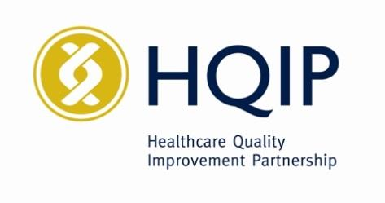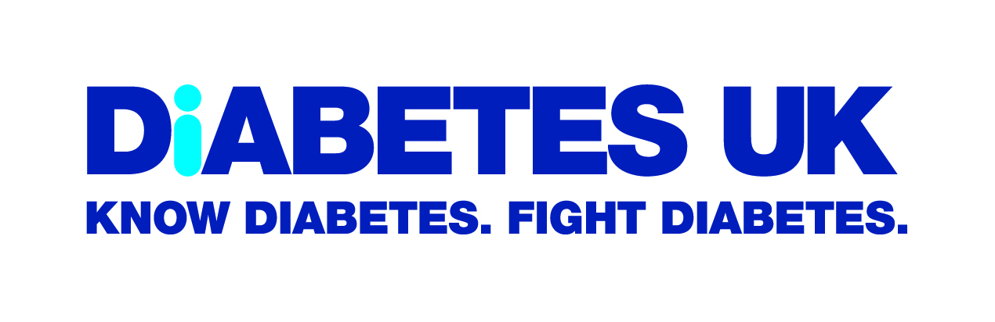 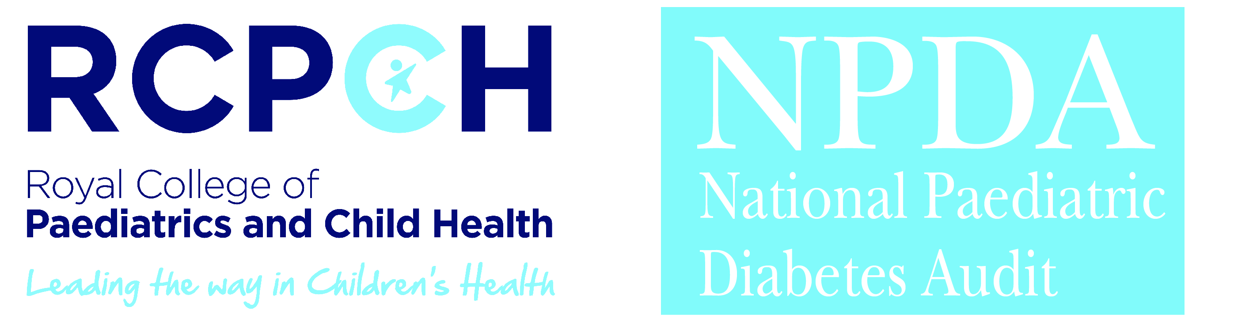

 

**National Diabetes Audit Quality Improvement Collaborative**

We at the National Diabetes Transition Audit (NDTA), delivered by NHS Digital and Diabetes UK, are supporting providers to further improve diabetes care. Through consultation, it was identified that this should focus on improving glucose control through transition.

This work will be undertaken through the creation of a National Diabetes Transition Audit Quality Improvement Collaborative (NDTAQIC). Quality Improvement Collaboratives have been shown to lead to improvement (Schouten et al, 2008). There is evidence that the following aspects to a collaborative lead to greater improvement: Teamwork; Teams that remain intact and continue to gather data; Facilitators perceived as being helpful; The sharing of improvement ideas in the first learning session; The prompt and frequent use of PDSA; Interactive learning sets and conference calls (Hulscher et al, 2013). The effectiveness of Quality Improvement Collaboratives may also depend upon the amount of control participants have over the processes being targeted (Power et al, 2014). These elements are therefore built into the design of NDTAQIC.

Please note that this programme is distinct from the Quality Improvement programme offered by the Royal College of Paediatrics and Child Health.

The below provides an overview of the draft workshop programme:

**Workshop overview (subject to change):**

|  |  |
| --- | --- |
| 9.00 – 9.30 | **Registration and Tea/Coffee** |
| 9.30 – 10.00 | Welcome and background |
| 10.00 – 10.45 | Setting aims and engaging others  *Building upon the application and post-application support to set measurable aims.*  *Patients, carers and colleagues on the team.* |
| 10.45 – 11.00 | **TEA/COFFEE** |
| 11.00 – 11.30 | Building an executable strategy  *The use and population of driver diagrams*. |
| 11.30 – 12.30 | Tracking improvement and capturing plans  *Reviewing data over time and developing a sustainable, local measurement plan*. |
| 12.30 – 1.00 | **LUNCH** |
| 1.00 – 1.20 | Learning from people with experience of diabetes |
| 1.20 – 2.20 | Analysing local practices and capturing plans  *Developing process maps and using reliable design to improve care* |
| 2.20 – 3.50 | PDSA & COM-B **(and tea/coffee break!)**  *The place and development of plan-do-study-act cycles within the model for improvement, and how they can be integrated with behaviour change theory.* |
| 3.50 – 4.10 | Driver action diagram  *Extending local driver diagrams and making commitments about the next steps.* |
| 4.10 - 4.30 | Present driver diagrams and describe next steps  *Learn what others are planning and have opportunity to win award!* |
| 4.30 – 4.45 | Next steps for the Collaborative |

After the workshop, participating teams will meet locally at least monthly to develop and implement their improvement work. As they do so, they will be supported with teleconferences in order to address local challenges and share learning across the collaborative.