Urgent Field Safety Notice
NovoPen® Echo® and NovoPen® 5
Ref. 2016050310

5 July 2017

Important safety information

Dear Healthcare Professional

Novo Nordisk A/S has detected that the insulin cartridge holder used in a number of NovoPen® Echo® and NovoPen® 5 batches may crack or break if exposed to certain chemicals in some household products, such as cleaning agents, sunscreen and food grease. NovoPen® Echo® and NovoPen® 5 are used for insulin treatment by people with diabetes. Novo Nordisk is already in contact with the MHRA regarding this issue.

Novo Nordisk urges diabetes patients using a NovoPen® Echo® and/or NovoPen® 5 from one of the affected batches to contact Novo Nordisk in order to replace the cartridge holder, which is just one component of the pens, as some could be damaged.

A picture of the cartridge holder is shown in Figure 1.

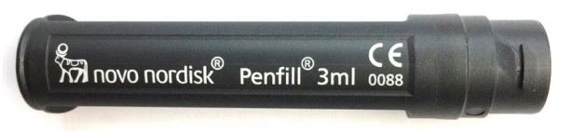
Figure 1. Cartridge holder used for NovoPen® Echo® and NovoPen® 5.

Description of the problem
If the cartridge holder comes in contact with certain chemicals it can crack or break. The reason for the cracking is that the plastic materials used for the cartridge holders in the affected batches can be weakened if exposed to certain chemicals found in some household products such as cleaning agents, sunscreen and food grease.

When cleaning the device as described in Instructions For Use, cracking of the cartridge holder is extremely unlikely.

Novo Nordisk has already changed the material of the cartridge holder back to the original type, where the issue with cracked and broken cartridge holders was not seen.

Using a device with a cracked or broken cartridge holder could result in the device delivering a smaller than intended dose leading to high blood sugar. The risk of experiencing high blood sugar with the use of a device with an affected cartridge holder is evaluated to be less than 0.1 %, i.e. only 1 in 1000 patients will experience high blood sugar due to an affected cartridge holder.

A patient might not experience any physical signs of high blood sugar (hyperglycaemia), but only be able to see it in on the blood sugar measurements.

Details of affected devices

The affected NovoPen® Echo® and NovoPen® 5 batch numbers distributed in the UK are shown in below tables. Please note the batch number can differ very slightly on the pen and the box that it comes in.

NovoPen® Echo® |  | NovoPen® 5
Batch number on carton | Batch number on pen | Batch number on carton | Batch number on pen
DUG0191 | DUG0191 | DVG1930-3 | DVG1930
DUG0192 | DUG0192 | DVG2199-2 | DVG2199
DUG0193 | DUG0193 | DVG3018-2 | DVG3018
DUG1613 | DUG1613 | EVG0506-2 | EVG0506
DUG1614 | DUG1614 | EVG0507-2 | EVG0507
DUG1615 | DUG1615 | EVG0615-2 | EVG0615
DUG1616 | DUG1616 | EVG0707-3 | EVG0707
DUG1708 | DUG1708 | EVG0902-2 | EVG0902
DUG1709 | DUG1709 | EVG2293-1 | EVG2293
DUG1775 | DUG1775 | EVG2906-1 | EVG2906
DUG1776 | DUG1776 | EVG2907-2 | EVG2907
DUG1777 | DUG1777 | EVG2910-2 | EVG2910
DUG1778 | DUG1778 | EVG3008-1 | EVG3008
DUG2049 | DUG2049 | EVG3112-2 | EVG3112
DUG2053 | DUG2053 | EVG6245-1 | EVG6245
DUG2054 | DUG2054 | EVG6822-3 | EVG6822
DUG2055 | DUG2055 | FVG7150-1 | FVG7150
DUG2055-1 | DUG2055 | FVG7564-2 | FVG7564
DUG2056 | DUG2056 | FVG7565-2 | FVG7565
DUG2058-1 | DUG2058 | FVG7565-5 | FVG7565
DUG2129-1 | DUG2129 | FVG7566-2 | FVG7566
DUG2218-1 | DUG2218 | FVG7567-2 | FVG7567
DUG2219-1 | DUG2219 | FVG7612-1 | FVG7612
DUG2343-1 | DUG2343 | FVG7613-1 | FVG7613
DVG1565-1 | DVG1565 | FVG7613-2 | FVG7613
DVG1566-1 | DVG1566 | FVG7616-1 | FVG7616
DVG1715-4 | DVG1715 | FVG7617-2 | FVG7617
DVG2297-4 | DVG2297 | FVG8531-2 | FVG8531
EVG2298-6 | EVG2298 | FVG8532-1 | FVG8532
EVG2299-6 | EVG2299 | FVG8654-2 | FVG8654
EVG2300-2 | EVG2300 | FVG8655-1 | FVG8655
EVG2908-2 | EVG2908 | FVG8657-2 | FVG8657
EVG2909-1 | EVG2909 | FVG8658-1 | FVG8658
EVG2915-1 | EVG2915 | FVG8659-1 | FVG8659
EVG3011-1 | EVG3011
EVG3011-3 | EVG3011
EVG3999-2 | EVG3999
EVG4253-3 | EVG4253
EVG5697-1 | EVG5697
EVG5698-2 | EVG5698
EVG5946-8 | EVG5946
EVG5962-1 | EVG5962
EVG5963-3 | EVG5963
EVG6823-2 | EVG6823
FVG7337-5 | FVG7337
FVG7364-1 | FVG7364
FVG7457-1 | FVG7457
FVG8212-3 | FVG8212
FVG8217-1 | FVG8217
FVG8218-1 | FVG8218
FVG8995-1 | FVG8995
FVG8997-4 | FVG8997
FVG8998-1 | FVG8998

Table 1. List of affected NovoPen® Echo® and NovoPen® 5 batches in the UK.

You can find the batch numbers printed on NovoPen® Echo® and NovoPen® 5 pens (Figure 2) and box (Figures 3) as indicated below.

The batch numbers are printed on NovoPen® Echo® and NovoPen® 5 as indicated below (Figure 2).

A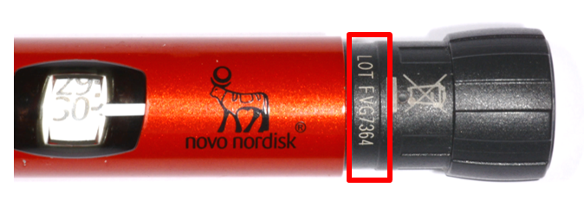 | B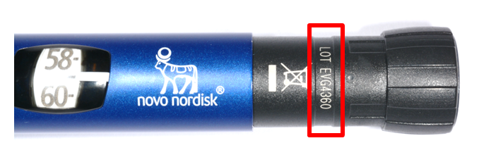
Figure 2. Red squares show where the batch number is located on (A) NovoPen® Echo® and (B) NovoPen® 5. Please note the pen will need to be dialled up in order to see the batch numbers. The NovoPen® Echo® can be red or blue in colour, whereas a NovoPen® 5 can be blue or grey.

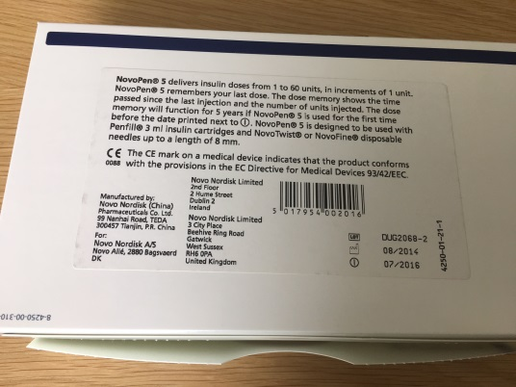

Figure 3. Red square shows where the batch number is located on the box.

This issue is being coordinated through UK pharmacists. We are also contacting patients via all appropriate networks including patient groups and the UK media. All relevant information for patients can be accessed through the Novo Nordisk website.

If you in your hospital or clinic are in possession of stock of NovoPen® Echo® and/or a NovoPen® 5 devices with the affected batches numbers, we kindly ask you to contact Alloga UK Limited to arrange their return on 01773 515124. Please contact Novo Nordisk for any other queries.

If you have patients that contact you that are using NovoPen® Echo® and/or NovoPen® 5 with one of the above-mentioned batch numbers:

- Attached is an information letter that may be shared with any patients that discuss who may have one of the affected NovoPen® Echo® and/or NovoPen® 5 devices. In the letter, patients are asked to check if they use a NovoPen® Echo® and/or NovoPen® 5 device from the affected batches and, if so, to contact Novo Nordisk for a replacement of the cartridge holder. A replacement may take up to seven days to arrive.

- For patients using a NovoPen® Echo® or NovoPen® 5 device with a batch number not mentioned above, there is no reason for concern and they can continue their treatment as usual.

Follow-up action

Novo Nordisk will continue to monitor adverse events and complaints reported with the affected batches and will communicate if any new relevant information becomes available.

Reporting

It is important that all adverse drug events and device incidents occurring during treatment using NovoPen® Echo® or NovoPen® 5 are reported in accordance with the local national legislation on spontaneous reporting of device incidents and adverse events.

Please report any complaints and adverse events. Reporting forms and information can be found at www.mhra.gov.uk/yellowcard.

Company contact point
If you have any questions or concerns, please refer to the Novo Nordisk website www.novonordisk.co.uk or contact Nordisk’s Customer Care line on 0845 600 5055. Novo Nordisk will extend opening hours of the Customer Care line to include weekends to support patients. Opening hours will be 8am-8pm Mon-Fri and 8am-4pm Sat-Sun.

The safety of patients is of utmost importance for Novo Nordisk. We strive to produce and distribute the highest quality products for your use. We sincerely apologise for this unfortunate situation and the concerns and inconvenience it may cause.

Yours sincerely,

Avideh Nazeri
Director of Clinical, Medical and Regulatory

Novo Nordisk Ltd

Further information
Novo Nordisk website www.novonordisk.co.uk
Novo Nordisk’s Customer Care line on 0845 600 5055

